Chapter
Forecasting Demand

Discussion Questions
1. Qualitative models incorporate subjective factors into the forecasting model. Qualitative models are useful when subjective factors are important. When quantitative data are difficult to obtain, qualitative models may be appropriate.
2. Approaches are qualitative and quantitative. Qualitative is relatively subjective; quantitative uses numeric models.
3. Short-range (under 3 months), medium-range (3 months to
3 years), and long-range (over 3 years).
4. The steps that should be used to develop a forecasting
system are:
(a) Determine the purpose and use of the forecast
(b) Select the item or quantities that are to be forecasted
(c) Determine the time horizon of the forecast
(d) Select the type of forecasting model to be used
(e) Gather the necessary data
(f) Validate the forecasting model
(g) Make the forecast
(h) Implement and evaluate the results
5. Any three of: sales planning, production planning and budgeting, cash budgeting, analyzing various operating plans.
6. There is no mechanism for growth in these models; they are built exclusively from historical demand values. Such methods will always lag trends.
7. Exponential smoothing is a weighted moving average where all previous values are weighted with a set of weights that decline exponentially.
8. MAD, MSE, and MAPE are common measures of forecast accuracy. To find the more accurate forecasting model, forecast with each tool for several periods where the demand outcome is known, and calculate MSE, MAPE, or MAD for each. The smaller error indicates the better forecast.
9. The Delphi technique involves:
(a) Assembling a group of experts in such a manner as to preclude direct communication between identifiable members of the group
(b) Assembling the responses of each expert to the questions or problems of interest
(c) Summarizing these responses
(d) Providing each expert with the summary of all responses
(e) Asking each expert to study the summary of the responses
and respond again to the questions or problems of interest.
(f) Repeating steps (b) through (e) several times as necessary to obtain convergence in responses. If convergence has not been obtained by the end of the fourth cycle, the responses at that time should probably be accepted and the process terminated—little additional convergence is likely if the process is continued.
10. A time series model predicts on the basis of the assumption that the future is a function of the past, whereas an associative model incorporates into the model the variables of factors that might influence the quantity being forecast.
11. A time series is a sequence of evenly spaced data points with the
four components of trend, seasonality, cyclical, and random variation.
12. When the smoothing constant, α, is large (close to 1.0), more weight is given to recent data; when α is low (close to 0.0), more weight is given to past data.
13. Seasonal patterns are of fixed duration and repeat regularly. Cycles vary in length and regularity. Seasonal indices allow
“generic” forecasts to be made specific to the month, week, etc., of the application.
14. Exponential smoothing weighs all previous values with a set of weights that decline exponentially. It can place a full weight on the most recent period (with an alpha of 1.0). This, in effect, is the naïve approach, which places all its emphasis on last period’s actual demand.
15. Adaptive forecasting refers to computer monitoring of tracking signals and self-adjustment if a signal passes its present limit.
16. Tracking signals alert the user of a forecasting tool to periods in which the forecast was in significant error.
17. The correlation coefficient measures the degree to which the independent and dependent variables move together. A negative value would mean that as X increases, Y tends to fall. The variables move together, but move in opposite directions.
18. Independent variable (x) is said to explain variations in the dependent variable (y).
19. Nearly every industry has seasonality. The seasonality must be filtered out for good medium-range planning (of production and inventory) and performance evaluation.
20. There are many examples. Demand for raw materials and component parts such as steel or tires is a function of demand for goods such as automobiles.
21. Obviously, as we go farther into the future, it becomes more difficult to make forecasts, and we must diminish our reliance on the forecasts.
Ethical Dilemma
This exercise, derived from an actual situation, deals as much with ethics as with forecasting. Here are a few points to consider:
- No one likes a system they don’t understand, and most
college presidents would feel uncomfortable with this one. It does offer the advantage of depoliticizing the funds al-
location if used wisely and fairly. But to do so means all parties must have input to the process (such as smoothing constants) and all data need to be open to everyone.
- The smoothing constants could be selected by an agreed-upon criteria (such as lowest MAD) or could be based on input from experts on the board as well as the college.
- Abuse of the system is tied to assigning alphas based on what results they yield, rather than what alphas make the most sense.
- Regression is open to abuse as well. Models can use many years of data yielding one result or few years yielding a
totally different forecast. Selection of associative variables can have a major impact on results as well.
Active Model Exercises*
ACTIVE MODEL 4.1: Moving Averages
1. What does the graph look like when n = 1?
The forecast graph mirrors the data graph but one period later.
2. What happens to the graph as the number of periods in the moving average increases?
The forecast graph becomes shorter and smoother.
3. What value for n minimizes the MAD for this data?
n = 1 (a naïve forecast)
ACTIVE MODEL 4.2: Exponential Smoothing
1. What happens to the graph when alpha equals zero?
The graph is a straight line. The forecast is the same in each period.
2. What happens to the graph when alpha equals one?
The forecast follows the same pattern as the demand (except for the first forecast) but is offset by one period. This is a naïve forecast.
3. Generalize what happens to a forecast as alpha increases.
As alpha increases the forecast is more sensitive to changes in demand.
4.2 (a) No, the data appear to have no consistent pattern
(see part d for graph).
 | Year | 1 | 2 | 3 | 4 | 5 | 6 | 7 | 8 | 9 | 10 | 11 | Forecast
 | Demand | 7 | 9 | 5 | 9.0 | 13.0 | 8.0 | 12.0 | 13.0 | 9.0 | 11.0 | 7.0
(b) | 3-year moving |  |  |  | 7.0 | 7.7 | 9.0 | 10.0 | 11.0 | 11.0 | 11.3 | 11.0 | 9.0
(c) | 3-year weighted |  |  |  | 6.4 | 7.8 | 11.0 | 9.6 | 10.9 | 12.2 | 10.5 | 10.6 | 8.4

*Active Models 4.1, 4.2, 4.3, and 4.4 appear on our Web site, www.pearsonglobaleditions.com/heizer.
4. At what level of alpha is the mean absolute deviation (MAD) minimized?
alpha = .16
ACTIVE MODEL 4.3: Exponential Smoothing with
Trend Adjustment
1. Scroll through different values for alpha and beta. Which smoothing constant appears to have the greater effect on the graph?
alpha
2. With beta set to zero, find the best alpha and observe the MAD. Now find the best beta. Observe the MAD. Does the addition of a trend improve the forecast?
alpha = .11, MAD = 2.59; beta above .6 changes the MAD (by a little) to 2.54.
ACTIVE MODEL 4.4: Trend Projections
1. What is the annual trend in the data?
10.54
2. Use the scrollbars for the slope and intercept to determine the values that minimize the MAD. Are these the same values that regression yields?
No, they are not the same values. For example, an intercept of 57.81 with a slope of 9.44 yields a MAD of 7.17.
End-of-Chapter Problems
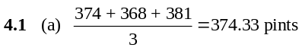
(b)
Week of | Pints Used |  | Weighted  Moving Average
August 31 | 360
September 7 | 389 |  | 381 × .1 = 38.1
September 14 | 410 |  | 368 × .3 = 110.4
September 21 | 381 |  | 374 × .6 = 224.4
September 28 | 368 |  | 372.9
October 5 | 374
 |  | Forecast 372.9
(c)
The forecast is 374.26.
Week of | Pints | Forecast | Forecasting  Error | Error  × .20 | Forecast
August 31 | 360 | 360 | 0 | 0 | 360
September 7 | 389 | 360 | 29 | 5.8 | 365.8
September 14 | 410 | 365.8 | 44.2 | 8.84 | 374.64
September 21 | 381 | 374.64 | 6.36 | 1.272 | 375.912
September 28 | 368 | 375.912 | –7.912 | –1.5824 | 374.3296
October 5 | 374 | 374.3296 | –.3296 | –.06592 | 374.2636
(d) The three-year moving average appears to give better
results.
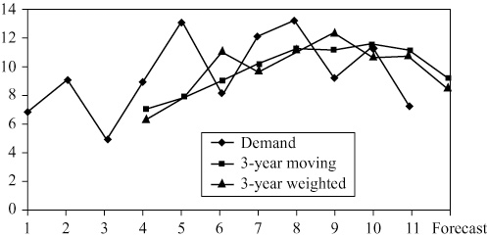
4.3 | Year | 1 | 2 | 3 | 4 | 5 | 6 | 7 | 8 | 9 | 10 | 11 | Forecast
 | Demand | 7 | 9.0 | 5.0 | 9.0 | 13.0 | 8.0 | 12.0 | 13.0 | 9.0 | 11.0 | 7.0
 | Naïve |  | 7.0 | 9.0 | 5.0 | 9.0 | 13.0 | 8.0 | 12.0 | 13.0 | 9.0 | 11.0 | 7.0
 | Exp. Smoothing | 6 | 6.4 | 7.4 | 6.5 | 7.5 | 9.7 | 9.0 | 10.2 | 11.3 | 10.4 | 10.6 | 9.2

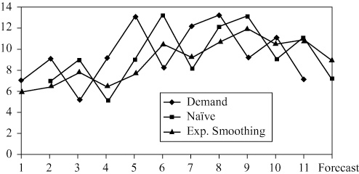
Naïve tracks the ups and downs best but lags the data by one period. Exponential smoothing is probably better because it smoothes the data and does not have as much variation.
TEACHING NOTE: Notice how well exponential smoothing forecasts the naïve.
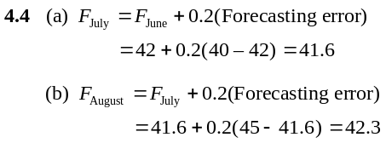
(c) The banking industry has a great deal of seasonality in its processing requirements
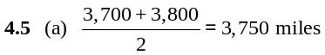
(b)
Year | Mileage | Two-Year  Moving Average |  | Error |  |  | |Error|
1 | 3,000
2 | 4,000
3 | 3,400 | 3,500 |  | –100 |  |  | 100
4 | 3,800 | 3,700 |  | 100 |  |  | 100
5 | 3,700 | 3,600 |  | 100 |  |  | 100
 |  |  | Totals |  | 100 |  |  | 300
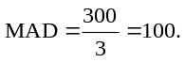
4.5 (c) Weighted 2 year M.A. with .6 weight for most recent year.
Year | Mileage | Forecast | Error | |Error|
1 | 3,000
2 | 4,000
3 | 3,400 | 3,600 | –200 | 200
4 | 3,800 | 3,640 | 160 | 160
5 | 3,700 | 3,640 | 60 | 60
 |  |  |  |  | 420
Forecast for year 6 is 3,740 miles.
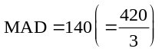
4.5 (d)
Year | Mileage | Forecast | Forecast  Error |  |  | Error ×  α = .50 | New  Forecast
1 | 3,000 | 3,000 | 0 |  |  | 0 | 3,000
2 | 4,000 | 3,000 | 1,000 |  |  | 500 | 3,500
3 | 3,400 | 3,500 | –100 |  |  | –50 | 3,450
4 | 3,800 | 3,450 | 350 |  |  | 175 | 3,625
5 | 3,700 | 3,625 | 75 |  |  | 38 | 3,663
 |  | Total |  | 1,325
The forecast is 3,663 miles.
4.6
 | Y Sales | X Period | X² | XY
January | 20 | 1 | 1 | 20
February | 21 | 2 | 4 | 42
March | 15 | 3 | 9 | 45
April | 14 | 4 | 16 | 56
May | 13 | 5 | 25 | 65
June | 16 | 6 | 36 | 96
July | 17 | 7 | 49 | 119
August | 18 | 8 | 64 | 144
September | 20 | 9 | 81 | 180
October | 20 | 10 | 100 | 200
November | 21 | 11 | 121 | 231
December | 23 | 12 | 144 | 276
Sum | 218 | 78 | 650 | 1,474
Average | 18.2 | 6.5
(a)
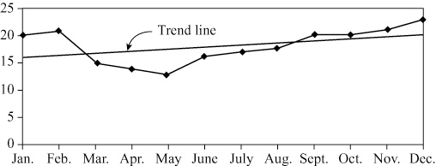
(b) [i] Naïve The coming January = December = 23
[ii] 3-month moving (20 + 21 + 23)/3 = 21.33
[iii] 6-month weighted [(0.1 × 17) + (.1 × 18)
+ (0.1 × 20) + (0.2 × 20)
+ (0.2 × 21) + (0.3 × 23)]/1.0
= 20.6
[iv] Exponential smoothing with alpha = 0.3
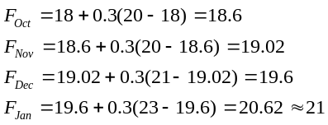
[v] Trend
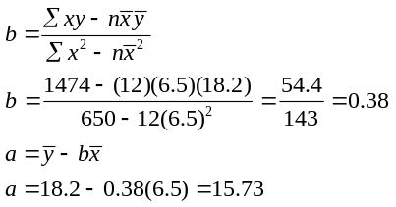
Forecast = 15.73 + .38(13) = 20.67, where next January
is the 13th month.
(c) Only trend provides an equation that can extend beyond one month
4.7 Present = Period (week) 6.
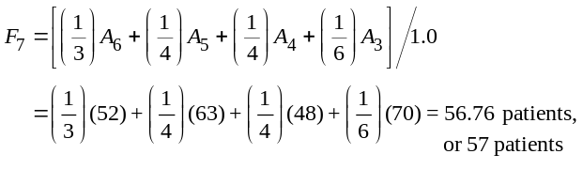
a) So:

where 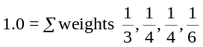
b) If the weights are 20, 15, 15, and 10, there will be no change in the forecast because these are the same relative weights as in part (a), i.e., 20/60, 15/60, 15/60, and 10/60.
c) If the weights are 0.4, 0.3, 0.2, and 0.1, then the forecast becomes 56.3, or 56 patients.
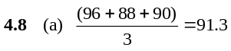
Table for Problem 4.9 (a, b, c)
 |  |  | Forecast |  |  | |Error|
 |  | Two-Month |  | Three-Month | Two-Month |  |  |  | Three-Month
 | Price per | Moving |  | Moving | Moving |  |  |  | Moving
Month | Chip | Average |  | Average | Average |  |  |  | Average
January | $1.80
February | 1.67
March | 1.70 | 1.735 |  |  | .035
April | 1.85 | 1.685 |  | 1.723 | .165 |  |  |  | .127
May | 1.90 | 1.775 |  | 1.740 | .125 |  |  |  | .160
June | 1.87 | 1.875 |  | 1.817 | .005 |  |  |  | .053
July | 1.80 | 1.885 |  | 1.873 | .085 |  |  |  | .073
August | 1.83 | 1.835 |  | 1.857 | .005 |  |  |  | .027
September | 1.70 | 1.815 |  | 1.833 | .115 |  |  |  | .133
October | 1.65 | 1.765 |  | 1.777 | .115 |  |  |  | .127
November | 1.70 | 1.675 |  | 1.727 | .025 |  |  |  | .027
December | 1.75 | 1.675 |  | 1.683 | .075 |  |  |  | .067
 |  |  |  | Totals |  |  | .750 |  |  | .793

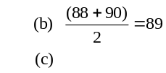
Temperature | 2 day M.A. | |Error| |  |  | (Error)² |  | Absolute |  | % Error
93 | — | — |  |  | — |  | —
94 | — | — |  |  | — |  | —
93 | 93.5 | 0.5 |  |  | 0.25 |  | 100(.5/93) |  | = 0.54%
95 | 93.5 | 1.5 |  |  | 2.25 |  | 100(1.5/95) |  | = 1.58%
96 | 94.0 | 2.0 |  |  | 4.00 |  | 100(2/96) |  | = 2.08%
88 | 95.5 | 7.5 |  |  | 56.25 |  | 100(7.5/88) |  | = 8.52%
90 | 92.0 | 2.0 |  |  | 4.00 |  | 100(2/90) |  | = 2.22%
 |  |  | 13.5 |  |  | 66.75 |  |  | 14.94%
MAD = 13.5/5 = 2.7
(d) MSE = 66.75/5 = 13.35
(e) MAPE = 14.94%/5 = 2.99%
4.9 (a, b) The computations for both the two- and three-month averages appear in the table; the results appear in the figure below.
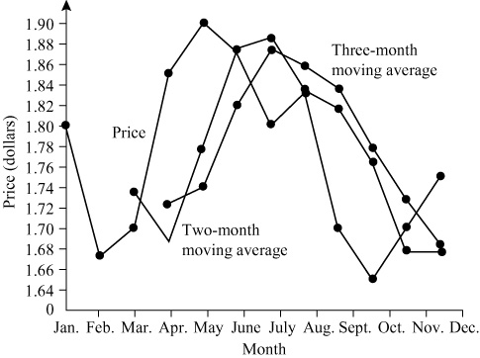
(c) MAD (two-month moving average) = .750/10 = .075
MAD (three-month moving average) = .793/9 = .088
Therefore, the two-month moving average seems to have performed better.
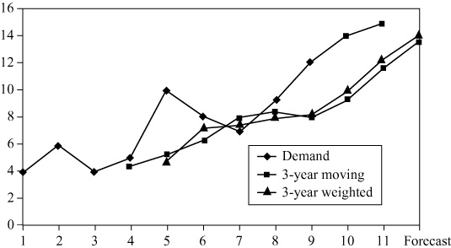
4.9 | (d) Table for Problem 4.9(d):
 |  |  |  | α = .1 |  |  |  |  |  | α = .3 |  |  |  |  |  |  | α = .5
 | Month | Price per Chip | Forecast |  | |Error| |  |  |  | Forecast |  | |Error| |  |  |  |  | Forecast |  | |Error|
 | January | $1.80 | $1.80 |  | $.00 |  |  |  | $1.80 |  | $.00 |  |  |  |  | $1.80 |  | $.00
 | February | 1.67 | 1.80 |  | .13 |  |  |  | 1.80 |  | .13 |  |  |  |  | 1.80 |  | .13
 | March | 1.70 | 1.79 |  | .09 |  |  |  | 1.76 |  | .06 |  |  |  |  | 1.74 |  | .04
 | April | 1.85 | 1.78 |  | .07 |  |  |  | 1.74 |  | .11 |  |  |  |  | 1.72 |  | .13
 | May | 1.90 | 1.79 |  | .11 |  |  |  | 1.77 |  | .13 |  |  |  |  | 1.78 |  | .12
 | June | 1.87 | 1.80 |  | .07 |  |  |  | 1.81 |  | .06 |  |  |  |  | 1.84 |  | .03
 | July | 1.80 | 1.80 |  | .00 |  |  |  | 1.83 |  | .03 |  |  |  |  | 1.86 |  | .06
 | August | 1.83 | 1.80 |  | .03 |  |  |  | 1.82 |  | .01 |  |  |  |  | 1.83 |  | .00
 | September | 1.70 | 1.81 |  | .11 |  |  |  | 1.82 |  | .12 |  |  |  |  | 1.83 |  | .13
 | October | 1.65 | 1.80 |  | .15 |  |  |  | 1.79 |  | .14 |  |  |  |  | 1.76 |  | .11
 | November | 1.70 | 1.78 |  | .08 |  |  |  | 1.75 |  | .05 |  |  |  |  | 1.71 |  | .01
 | December | 1.75 | 1.77 |  | .02 |  |  |  | 1.73 |  | .02 |  |  |  |  | 1.70 |  | .05
 |  | Totals |  |  |  |  | $.86 |  |  |  |  |  | $.86 |  |  |  |  |  | $.81
 |  | MAD (total/12) |  |  |  | $.072 |  |  |  |  |  | $.072 |  |  |  |  |  | $.0675
α = .5 is preferable, using MAD, to α = .1 or α = .3. One could
also justify excluding the January error and then dividing by
n = 11 to compute the MAD. These numbers would be $.078
(for α = .1), $.078 (for α = .3), and $.074 (for α = .5).

(c) The forecasts are about the same.
4.10 |  | Year | 1 | 2 | 3 | 4 | 5 | 6 | 7 | 8 | 9 | 10 | 11 | Forecast
 |  | Demand | 4 | 6 | 4 | 5.0 | 10.0 | 8.0 | 7.0 | 9.0 | 12.0 | 14.0 | 15.0
 | (a) | 3-year moving |  |  |  | 4.7 | 5.0 | 6.3 | 7.7 | 8.3 | 8.0 | 9.3 | 11.7 | 13.7
 | (b) | 3-year weighted |  |  |  | 4.5 | 5.0 | 7.3 | 7.8 | 8.0 | 8.3 | 10.0 | 12.3 | 14.0

4.11 | (a) | Year | 1 | 2 | 3 | 4 | 5 | 6 | 7 | 8 | 9 | 10 | 11 | Forecast
 |  | Demand | 4 | 6.0 | 4.0 | 5.0 | 10.0 | 8.0 | 7.0 | 9.0 | 12.0 | 14.0 | 15.0
 |  | Exp. Smoothing | 5 | 4.7 | 5.1 | 4.8 | 4.8 | 6.4 | 6.9 | 6.9 | 7.5 | 8.9 | 10.4 | 11.8

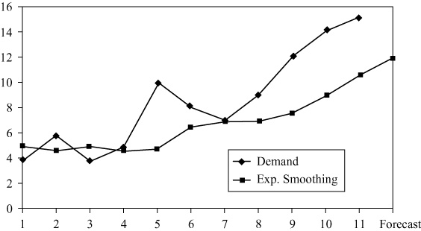
4.12
(b) |Error| = |Actual – Forecast|
 |  | Year | 1 | 2 | 3 | 4 | 5 | 6 | 7 | 8 | 9 | 10 | 11 | MAD
 |  | Exp. smoothing | 1 | 1.3 | 1.1 | 0.2 | 5.2 | 1.6 | 0.1 | 2.1 | 4.5 | 5.1 | 4.6 | 2.4
 |  | These calculations were completed in Excel. Calculations are slightly different in Excel OM and POM for Windows due to rounding differences.

t | Day | Actual  Demand | Forecast  Demand
1 | Monday | 88 | 88
2 | Tuesday | 72 | 88
3 | Wednesday | 68 | 84
4 | Thursday | 48 | 80
5 | Friday |  | 72 | ← Answer
F_{t} = F_{t–1} + α(A_{t–1} – F_{t–1})
Let α = .25. Let Monday forecast demand = 88
F₂ = 88 + .25(88 – 88) = 88 + 0 = 88
F₃ = 88 + .25(72 – 88) = 88 – 4 = 84
F₄ = 84 + .25(68 – 84) = 84 – 4 = 80
F₅ = 80 + .25(48 – 80) = 80 – 8 = 72
4.13 (a) Exponential smoothing, α = 0.6:
 |  | Exponential | Absolute
Year | Demand | Smoothing α = 0.6 | Deviation
1 | 45 | 41 | 4.0
2 | 50 | 41.0 + 0.6(45–41) = 43.4 | 6.6
3 | 52 | 43.4 + 0.6(50–43.4) = 47.4 | 4.6
4 | 56 | 47.4 + 0.6(52–47.4) = 50.2 | 5.8
5 | 58 | 50.2 + 0.6(56–50.2) = 53.7 | 4.3
6 | ? | 53.7 + 0.6(58–53.7) = 56.3
Σ = 25.3
MAD = 5.06
Exponential smoothing, α = 0.9:
 |  | Exponential | Absolute
Year | Demand | Smoothing α = 0.9 | Deviation
1 | 45 | 41 | 4.0
2 | 50 | 41.0 + 0.9(45–41) = 44.6 | 5.4
3 | 52 | 44.6 + 0.9(50–44.6 ) = 49.5 | 2.5
4 | 56 | 49.5 + 0.9(52–49.5) = 51.8 | 4.2
5 | 58 | 51.8 + 0.9(56–51.8) = 55.6 | 2.4
6 | ? | 55.6 + 0.9(58–55.6) = 57.8
Σ = 18.5
MAD = 3.7
(b) 3-year moving average:
 |  | Three-Year | Absolute
Year | Demand | Moving Average | Deviation
1 | 45
2 | 50
3 | 52
4 | 56 | (45 + 50 + 52)/3 = 49 | 7
5 | 58 | (50 + 52 + 56)/3 = 52.7 | 5.3
6 | ? | (52 + 56 + 58)/3 = 55.3
Σ = 12.3
MAD = 6.2
(c) Trend projection:
 |  |  | Absolute
Year | Demand | Trend Projection | Deviation
1 | 45 | 42.6 + 3.2 × 1 = 45.8 | 0.8
2 | 50 | 42.6 + 3.2 × 2 = 49.0 | 1.0
3 | 52 | 42.6 + 3.2 × 3 = 52.2 | 0.2
4 | 56 | 42.6 + 3.2 × 4 = 55.4 | 0.6
5 | 58 | 42.6 + 3.2 × 5 = 58.6 | 0.6
6 | ? | 42.6 + 3.2 × 6 = 61.8
Σ = 3.2
MAD = 0.64
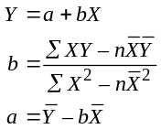
X | Y | XY | X²
1 | 45 | 45 | 1
2 | 50 | 100 | 4
3 | 52 | 156 | 9
4 | 56 | 224 | 16
5 | 58 | 290 | 25
Then: ΣX = 15, ΣY = 261, ΣXY = 815, ΣX² = 55, = 3, = 52.2 Therefore:
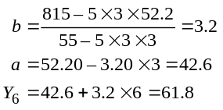
(d) Comparing the results of the forecasting methodologies for parts (a), (b), and (c).
Forecast Methodology | MAD
Exponential smoothing, α = 0.6 | 5.06
Exponential smoothing, α = 0.9 | 3.7
3-year moving average | 6.2
Trend projection | 0.64
Based on a mean absolute deviation criterion, the trend projection is to be preferred over the exponential smoothing with α = 0.6, exponential smoothing with α = 0.9, or the 3-year moving average forecast methodologies.
4.14
Method 1: MAD: (0.20 + 0.05 + 0.05 + 0.20)/4 = .125 ← better
MSE : (0.04 + 0.0025 + 0.0025 + 0.04)/4 = .021
Method 2: MAD: (0.1 + 0.20 + 0.10 + 0.11) / 4 = .1275
MSE : (0.01 + 0.04 + 0.01 + 0.0121) / 4 = .018 ← better
4.15
 |  | Forecast Three-Year | Absolute
Year | Sales | Moving Average | Deviation
2005 | 450
2006 | 495
2007 | 518
2008 | 563 | (450 + 495 + 518)/3 = 487.7 | 75.3
2009 | 584 | (495 + 518 + 563)/3 = 525.3 | 58.7
2010 |  | (518 + 563 + 584)/3 = 555.0
 |  | Σ = 134
 |  | MAD = 67

4.16
Year | Time Period X | Sales Y |  | X² |  | XY
2005 | 1 | 450 |  | 1 |  | 450
2006 | 2 | 495 |  | 4 |  | 990
2007 | 3 | 518 |  | 9 |  | 1554
2008 | 4 | 563 |  | 16 |  | 2252
2009 | 5 | 584 |  | 25 |  | 2920
 |  | Σ = 2610 |  | Σ = 55 |  | Σ = 8166
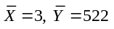
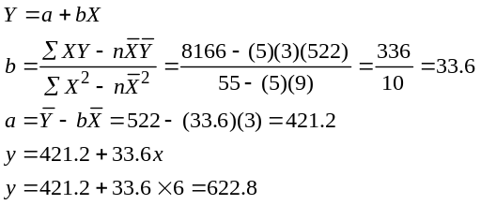
Year | Sales | Forecast Trend | Absolute Deviation
2005 | 450 | 454.8 | 4.8
2006 | 495 | 488.4 | 6.6
2007 | 518 | 522.0 | 4.0
2008 | 563 | 555.6 | 7.4
2009 | 584 | 589.2 | 5.2
2010 |  | 622.8
 |  |  | Σ = 28
 |  |  | MAD = 5.6
4.17
 |  | Forecast Exponential | Absolute
Year | Sales | Smoothing α = 0.6 | Deviation
2005 | 450 | 410.0 | 40.0
2006 | 495 | 410 + 0.6(450 – 410) = 434.0 | 61.0
2007 | 518 | 434 + 0.6(495 – 434) = 470.6 | 47.4
2008 | 563 | 470.6 + 0.6(518 – 470.6) = 499.0 | 64.0
2009 | 584 | 499 + 0.6(563 – 499) = 537.4 | 46.6
2010 |  | 537.4 + 0.6(584 – 537.4) = 565.6
 |  | Σ = 259
 |  | MAD = 51.8

 |  | Forecast Exponential | Absolute
Year | Sales | Smoothing α = 0.9 | Deviation
2005 | 450 | 410.0 | 40.0
2006 | 495 | 410 + 0.9(450 – 410) = 446.0 | 49.0
2007 | 518 | 446 + 0.9(495 – 446) = 490.1 | 27.9
2008 | 563 | 490.1 + 0.9(518 – 490.1) = 515.2 | 47.8
2009 | 584 | 515.2 + 0.9(563 – 515.2) = 558.2 | 25.8
2010 |  | 558.2 + 0.9(584 – 558.2) = 581.4
 |  | Σ = 190.5
 |  | MAD = 38.1
(Refer to Solved Problem 4.1)
For α = 0.3, absolute deviations for 2005–2009 are 40.0, 73.0, 74.1, 96.9, 88.8, respectively. So the MAD = 372.8/5 = 74.6.
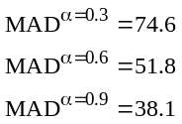
Because it gives the lowest MAD, the smoothing constant of
α = 0.9 gives the most accurate forecast.
4.18 We need to find the smoothing constant α. We know in general that F_{t} = F_{t–1} + α(A_{t–1} – F_{t–1}); t = 2, 3, 4. Choose either
t = 3 or t = 4 (t = 2 won’t let us find α because F₂ = 50 = 50 + α(50 – 50) holds for any α). Let’s pick t = 3. Then F₃ = 48 = 50 + α(42 – 50)
or 48 = 50 + 42α – 50α
or –2 = –8α
So, .25 = α
Now we can find F₅ : F₅ = 50 + α(46 – 50)
F₅ = 50 + 46α – 50α = 50 – 4α
For α = .25, F₅ = 50 – 4(.25) = 49
The forecast for time period 5 = 49 units.
4.19 Trend adjusted exponential smoothing: α = 0.1, β = 0.2
 |  | Unadjusted |  | Adjusted
Month | Income | Forecast | Trend | Forecast | |Error| |  |  | Error²
February | 70.0 | 65.0 | 0.0 | 65 | 5.0 |  |  | 25.0
March | 68.5 | 65.5 | 0.1 | 65.6 | 2.9 |  |  | 8.4
April | 64.8 | 65.9 | 0.16 | 66.05 | 1.2 |  |  | 1.6
May | 71.7 | 65.92 | 0.13 | 66.06 | 5.6 |  |  | 31.9
June | 71.3 | 66.62 | 0.25 | 66.87 | 4.4 |  |  | 19.7
July | 72.8 | 67.31 | 0.33 | 67.64 | 5.2 |  |  | 26.6
August |  | 68.16 |  | 68.60 |  | 24.3 |  |  | 113.2
MAD = 24.3/6 = 4.05, MSE = 113.2/6 = 18.87. Note that all numbers are rounded.
Note: To use POM for Windows to solve this problem, a period 0, which contains the initial forecast and initial trend, must be added.
4.20 Trend adjusted exponential smoothing: α = 0.1, β = 0.8
 |  | Unadjusted |  | Adjusted
Month | Demand (y) | Forecast | Trend | Forecast | Error |  |  | |Error| |  |  | Error²
February | 70.0 | 65.0 | 0 | 65.0 | 5.00 |  |  | 5.0 |  |  | 25.00
March | 68.5 | 65.5 | 0.4 | 65.9 | 2.60 |  |  | 2.6 |  |  | 6.76
April | 64.8 | 66.16 | 0.61 | 66.77 | –1.97 |  |  | 1.97 |  |  | 3.87
May | 71.7 | 66.57 | 0.45 | 67.02 | 4.68 |  |  | 4.68 |  |  | 21.89
June | 71.3 | 67.49 | 0.82 | 68.31 | 2.99 |  |  | 2.99 |  |  | 8.91
July | 72.8 | 68.61 | 1.06 | 69.68 | 3.12 |  |  | 3.12 |  |  | 9.76
Totals | 419.1 |  |  |  |  | 16.42 |  |  | 20.36 |  |  | 76.19
Average | 69.85 |  |  |  | 2.74 |  |  | 3.39 |  |  | 12.70
August Forecast |  |  |  | 71.30 | (Bias) |  |  | (MAD) |  |  | (MSE)
Based upon the MSE criterion, the exponential smoothing with α = 0.1, β = 0.8 is to be preferred
over the exponential smoothing with α = 0.1, β = 0.2. Its MSE of 12.70 is lower. Its MAD of 3.39 is
also lower than that in Problem 4.19.
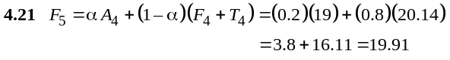
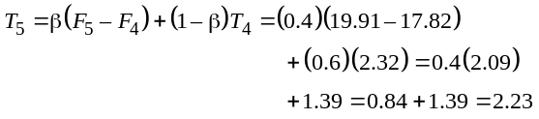
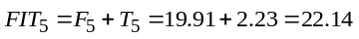
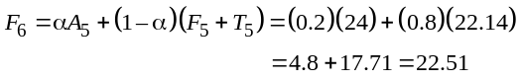
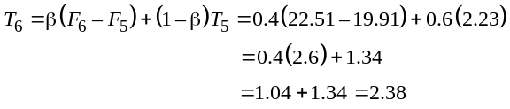
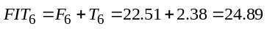
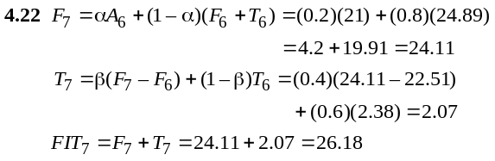
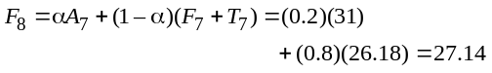
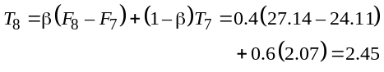
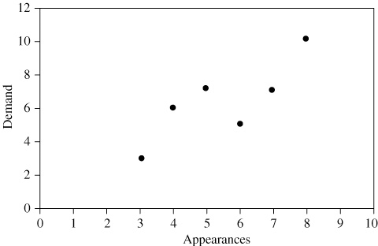
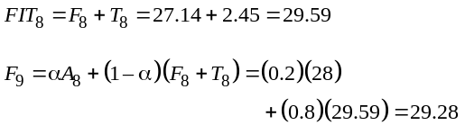
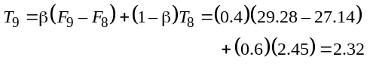
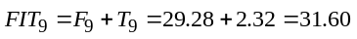

4.23 Students must determine the naïve forecast for the four months. The naïve forecast for March is the February actual of 83, etc.
(a) |  | Actual | Forecast | |Error| |  |  | |% Error|
 | March | 101 | 120 | 19 |  |  | 100 (19/101) = 18.81%
 | April | 96 | 114 | 18 |  |  | 100 (18/96) = 18.75%
 | May | 89 | 110 | 21 |  |  | 100 (21/89) = 23.60%
 | June | 108 | 108 | 0 |  |  | 100 (0/108) = 0%
 |  |  |  |  | 58 |  |  |  | 61.16%
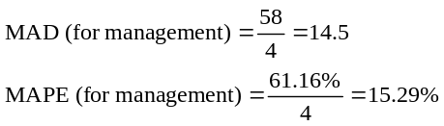
(b) |  | Actual | Naïve | |Error| |  |  | |% Error|
 | March | 101 | 83 | 18 |  |  | 100 (18/101) = 17.82%
 | April | 96 | 101 | 5 |  |  | 100 (5/96) = 5.21%
 | May | 89 | 96 | 7 |  |  | 100 (7/89) = 7.87%
 | June | 108 | 89 | 19 |  |  | 100 (19/108) = 17.59%
 |  |  |  |  | 49 |  |  | 48.49%
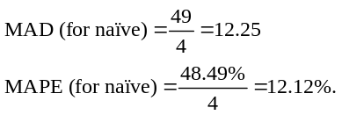
Naïve outperforms management.
(c) MAD for the manager’s technique is 14.5, while MAD for the naïve forecast is only 12.25. MAPEs are 15.29% and 12.12%, respectively. So the naïve method is better.
4.24 (a) Graph of demand
The observations obviously do not form a straight line but do tend to cluster about a straight line over the range shown.
(b) Least-squares regression:
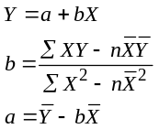
Assume
Appearances X | Demand Y | X² | Y² | XY
3 | 3 | 9 | 9 | 9
4 | 6 | 16 | 36 | 24
7 | 7 | 49 | 49 | 49
6 | 5 | 36 | 25 | 30
8 | 10 | 64 | 100 | 80
5 | 7 | 25 | 49 | 35
9 | ?
ΣX = 33, ΣY = 38, ΣXY = 227, ΣX² = 199, = 5.5, = 6.33. Therefore:
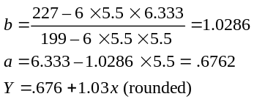
The following figure shows both the data and the resulting equation:

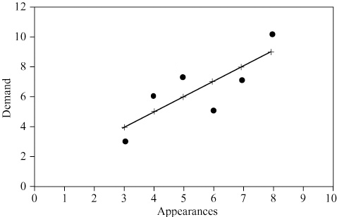
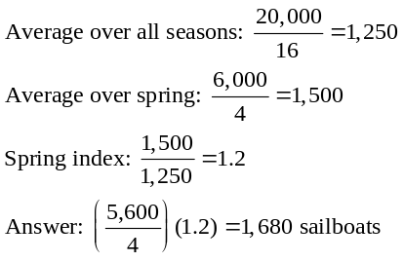(c) If there are nine performances by Stone Temple Pilots, the estimated sales are:
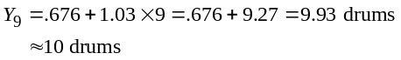

(d) R = .82 is the correlation coefficient, and R² = .68 means 68% of the variation in sales can be explained by TV appearances.
4.25
 | Number of
 | Accidents
Month | (y) |  |  | x |  |  | xy |  |  | x²
January | 30 |  |  | 1 |  |  | 30 |  |  | 1
February | 40 |  |  | 2 |  |  | 80 |  |  | 4
March | 60 |  |  | 3 |  |  | 180 |  |  | 9
April | 90 |  |  | 4 |  |  | 360 |  |  | 16
Totals |  | 220 |  |  | 10 |  |  | 650 |  |  | 30
Averages | = 55 |  |  | = 2.5
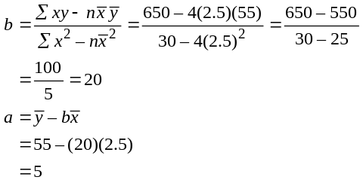
The regression line is y = 5 + 20x. The forecast for May (x = 5) is y = 5 + 20(5) = 105.
4.26
Season | Year₁  Demand | Year₂  Demand | Average  Year₁−Year₂  Demand | Average  Season  Demand | Seasonal  Index | Year₃  Demand
Fall | 200 | 250 | 225.0 | 250 | 0.90 | 270
Winter | 350 | 300 | 325.0 | 250 | 1.30 | 390
Spring | 150 | 165 | 157.5 | 250 | 0.63 | 189
Summer | 300 | 285 | 292.5 | 250 | 1.17 | 351
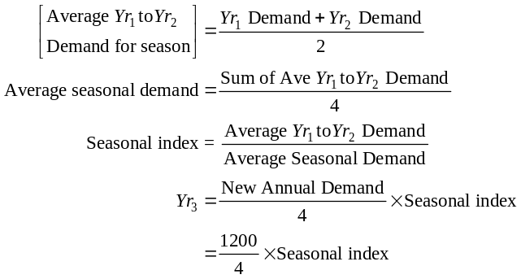

4.27
 | Winter | Spring | Summer | Fall
2006 | 1,400 | 1,500 | 1,000 | 600
2007 | 1,200 | 1,400 | 2,100 | 750
2008 | 1,000 | 1,600 | 2,000 | 650
2009 | 900 | 1,500 | 1,900 | 500
 | 4,500 | 6,000 | 7,000 | 2,500
4.28
Quarter | 2007 | 2008 | 2009 | Average  Demand | Average  Quarterly  Demand | Seasonal  Index
Winter | 73 | 65 | 89 | 75.67 | 106.67 | 0.709
Spring | 104 | 82 | 146 | 110.67 | 106.67 | 1.037
Summer | 168 | 124 | 205 | 165.67 | 106.67 | 1.553
Fall | 74 | 52 | 98 | 74.67 | 106.67 | 0.700
4.29 2011 is 25 years beyond 1986. Therefore, the 2011 quarter numbers are 101 through 104.
 |  |  |  | (5)
 | (2) | (3) | (4) | Adjusted
(1) | Quarter | Forecast | Seasonal | Forecast
Quarter | Number | (77 + .43Q) | Factor | [(3) × (4)]
Winter | 101 | 120.43 | .8 | 96.344
Spring | 102 | 120.86 | 1.1 | 132.946
Summer | 103 | 121.29 | 1.4 | 169.806
Fall | 104 | 121.72 | .7 | 85.204
4.30 Given Y = 36 + 4.3X
(a) Y = 36 + 4.3(70) = 337
(b) Y = 36 + 4.3(80) = 380
(c) Y = 36 + 4.3(90) = 423
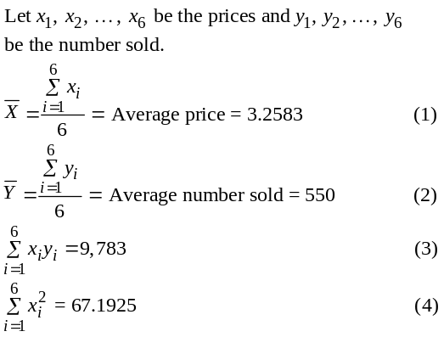4.31

4.33 (a) See the table below.
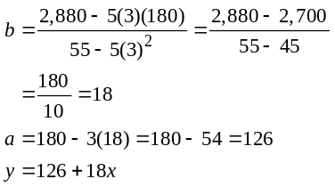

For next year (x = 6), the number of transistors (in millions) is forecasted as y = 126 + 18(6) = 126 + 108 = 234.

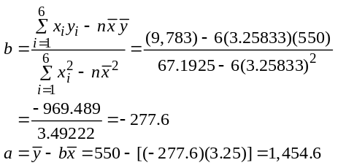Then y = a + bx, where y = number sold, x = price, and

So at x = 2.80, y = 1,454.6 – 277.6($2.80) = 677.32. Now round to the nearest integer: Answer: 677 lattes.
4.32 (a) | x | y | xy | x²
 | 16 | 330 | 5,280 | 256
 | 12 | 270 | 3,240 | 144
 | 18 | 380 | 6,840 | 324
 | 14 | 300 | 4,200 | 196
 | 60 | 1,280 | 19,560 | 920
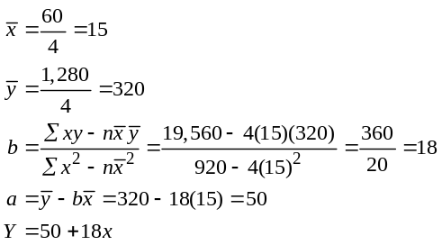
(b) If the forecast is for 20 guests, the bar sales forecast
is 50 + 18(20) = $410. Each guest accounts for an
additional $18 in bar sales.
Table for Problem 4.33
 | Year |  | Transistors
 | (x) |  | (y) |  |  | xy |  |  | x² |  |  | 126 + 18x | Error | Error² |  |  | |% Error|
 | 1 |  | 140 |  |  | 140 |  |  | 1 |  |  | 144 | –4 | 16 |  |  | 100 (4/140) = 2.86%
 | 2 |  | 160 |  |  | 320 |  |  | 4 |  |  | 162 | –2 | 4 |  |  | 100 (2/160) = 1.25%
 | 3 |  | 190 |  |  | 570 |  |  | 9 |  |  | 180 | 10 | 100 |  |  | 100 (10/190) = 5.26%
 | 4 |  | 200 |  |  | 800 |  |  | 16 |  |  | 198 | 2 | 4 |  |  | 100 (2/200) = 1.00%
 | 5 |  | 210 |  |  | 1,050 |  |  | 25 |  |  | 216 | –6 | 36 |  |  | 100 (6/210) = 2.86%
Totals | 15 |  |  | 900 |  |  | 2,800 |  |  | 55 |  |  |  |  | 160 |  |  | 13.23%
= | 3 |  | = 180
(b) MSE = 160/5 = 32
(c) MAPE = 13.23%/5 = 2.65%
4.34 Y = 7.5 + 3.5X1 + 4.5X2 + 2.5X3
(a) 28
(b) 43
(c) 58
4.35 (a) = 13,473 + 37.65(1860) = 83,502
(b) The predicted selling price is $83,502, but this is the average price for a house of this size. There are other
factors besides square footage that will impact the selling price of a house. If such a house sold for $95,000, then these other factors could be contributing to the additional value.
(c) Some other quantitative variables would be age of the house, number of bedrooms, size of the lot, and size of the garage, etc.
(d) Coefficient of determination = (0.63)² = 0.397. This means that only about 39.7% of the variability in the sales price of a house is explained by this regression model that only includes square footage as the explanatory variable.
4.36 (a) Given: Y = 90 + 48.5X1 + 0.4X2 where:
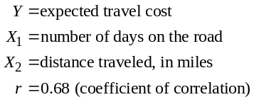
If:
Number of days on the road → X₁ = 5 and distance
traveled → X₂ = 300
then:
Y = 90 + 48.5 × 5 + 0.4 × 300 = 90 + 242.5 + 120 = 452.5
Therefore, the expected cost of the trip is $452.50.
(b) The reimbursement request is much higher than predicted by the model. This request should probably be questioned by the accountant.
(c) A number of other variables should be included, such as:
1. the type of travel (air or car)
2. conference fees, if any
3. costs of entertaining customers
4. other transportation costs—cab, limousine, special tolls, or parking
In addition, the correlation coefficient of 0.68 is not exceptionally high. It indicates that the model explains approximately 46% of the overall variation in trip cost. This correlation coefficient would suggest that the model is not a particularly good one.
4.37 (a, b)
Period | Demand | Forecast | Error |  | Running sum |  | |error|
1 | 20 | 20 | 0.00 |  | 0.00 |  | 0.00
2 | 21 | 20 | 1.00 |  | 1.00 |  | 1.00
3 | 28 | 20.5 | 7.50 |  | 8.50 |  | 7.50
4 | 37 | 24.25 | 12.75 |  | 21.25 |  | 12.75
5 | 25 | 30.63 | –5.63 |  | 15.63 |  | 5.63
6 | 29 | 27.81 | 1.19 |  | 16.82 |  | 1.19
7 | 36 | 28.41 | 7.59 |  | 24.41 |  | 7.59
8 | 22 | 32.20 | –10.20 |  | 14.21 |  | 10.20
9 | 25 | 27.11 | –2.10 |  | 12.10 |  | 2.10
10 | 28 | 26.05 | 1.95 |  | 14.05 |  | 1.95
 |  |  |  |  |  | MAD5.00
Cumulative error = 14.05; MAD = 5 Tracking = 14.05/5 = 2.82
4.38 (a) least squares equation: Y = –0.158 + 0.1308X
(b) Y = –0.158 + 0.1308(22) = 2.719 million
(c) coefficient of correlation = r = 0.966
coefficient of determination = r² = 0.934
4.39
Year X |  | Patients Y |  |  | X² |  |  | Y² |  |  | XY
1 |  | 36 |  |  | 1 |  |  | 1,296 |  |  | 36
2 |  | 33 |  |  | 4 |  |  | 1,089 |  |  | 66
3 |  | 40 |  |  | 9 |  |  | 1,600 |  |  | 120
4 |  | 41 |  |  | 16 |  |  | 1,681 |  |  | 164
5 |  | 40 |  |  | 25 |  |  | 1,600 |  |  | 200
6 |  | 55 |  |  | 36 |  |  | 3,025 |  |  | 330
7 |  | 60 |  |  | 49 |  |  | 3,600 |  |  | 420
8 |  | 54 |  |  | 64 |  |  | 2,916 |  |  | 432
9 |  | 58 |  |  | 81 |  |  | 3,364 |  |  | 522
10 |  | 61 |  |  | 100 |  |  | 3,721 |  |  | 610
55 |  |  | 478 |  |  | 385 |  |  | 23,892 |  |  | 2,900
Given: Y = a + bX where:
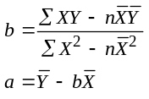
and ΣX = 55, ΣY = 478, ΣXY = 2900, ΣX² = 385, ΣY² = 23892,
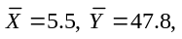 Then:
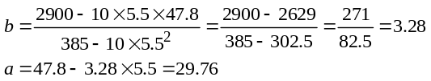
and Y = 29.76 + 3.28X. For:
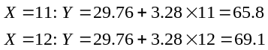
Therefore:
Year 11 → 65.8 patients
Year 12 → 69.1 patients
The model “seems” to fit the data pretty well. One should, however, be more precise in judging the adequacy of the model.
Two possible approaches are computation of (a) the correlation coefficient, or (b) the mean absolute deviation. The correlation coefficient:
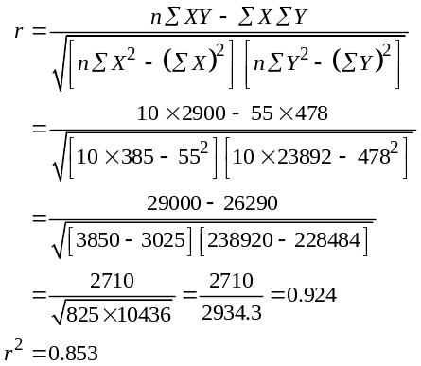
The coefficient of determination of 0.853 is quite respectable—indicating our original judgment of a “good” fit was appropriate.

Year | Patients | Trend |  | Absolute
X | Y | Forecast | Deviation | Deviation
1 | 36 | 29.8 + 3.28 × 1 = 33.1 | 2.9 | 2.9
2 | 33 | 29.8 + 3.28 × 2 = 36.3 | –3.3 | 3.3
3 | 40 | 29.8 + 3.28 × 3 = 39.6 | 0.4 | 0.4
4 | 41 | 29.8 + 3.28 × 4 = 42.9 | –1.9 | 1.9
5 | 40 | 29.8 + 3.28 × 5 = 46.2 | –6.2 | 6.2
6 | 55 | 29.8 + 3.28 × 6 = 49.4 | 5.6 | 5.6
7 | 60 | 29.8 + 3.28 × 7 = 52.7 | 7.3 | 7.3
8 | 54 | 29.8 + 3.28 × 8 = 56.1 | –2.1 | 2.1
9 | 58 | 29.8 + 3.28 × 9 = 59.3 | –1.3 | 1.3
10 | 61 | 29.8 + 3.28 × 10 = 62.6 | –1.6 | 1.6
 |  |  |  | Σ = 32.6
 |  |  |  | MAD = 3.26
The MAD is 3.26—this is approximately 7% of the average number of patients and 10% of the minimum number of patients. We also see absolute deviations, for years 5, 6, and 7 in the range
5.6–7.3. The comparison of the MAD with the average and minimum number of patients and the comparatively large deviations during the middle years indicate that the forecast model is not exceptionally accurate. It is more useful for predicting general trends than the actual number of patients to be seen in a specific year.
4.40
 | Crime |  |  | Patients
Year | Rate X |  |  | Y |  |  | X² |  |  | Y² |  |  | XY
1 | 58.3 |  |  | 36 |  |  | 3,398.9 |  |  | 1,296 |  |  | 2,098.8
2 | 61.1 |  |  | 33 |  |  | 3,733.2 |  |  | 1,089 |  |  | 2,016.3
3 | 73.4 |  |  | 40 |  |  | 5,387.6 |  |  | 1,600 |  |  | 2,936.0
4 | 75.7 |  |  | 41 |  |  | 5,730.5 |  |  | 1,681 |  |  | 3,103.7
5 | 81.1 |  |  | 40 |  |  | 6,577.2 |  |  | 1,600 |  |  | 3,244.0
6 | 89.0 |  |  | 55 |  |  | 7,921.0 |  |  | 3,025 |  |  | 4,895.0
7 | 101.1 |  |  | 60 |  |  | 10,221.2 |  |  | 3,600 |  |  | 6,066.0
8 | 94.8 |  |  | 54 |  |  | 8,987.0 |  |  | 2,916 |  |  | 5,119.2
9 | 103.3 |  |  | 58 |  |  | 10,670.9 |  |  | 3,364 |  |  | 5,991.4
10 | 116.2 |  |  | 61 |  |  | 13,502.4 |  |  | 3,721 |  |  | 7,088.2
Column Totals |  | 854.0 |  |  | 478 |  |  | 76,129.9 |  |  | 23,892 |  | 42,558.6
Given: Y = a + bX where
and ΣX = 854, ΣY = 478, ΣXY = 42558.6, ΣX² = 76129.9,
ΣY² = 23892, = 85.4, = 47.8. Then:
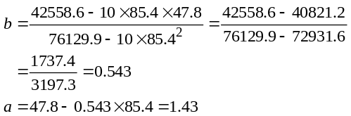
and Y = 1.43 + 0.543X
For:
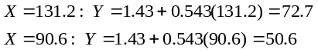
Therefore:
Crime rate = 131.2 → 72.7 patients
Crime rate = 90.6 → 50.6 patients
Note that rounding differences occur when solving with Excel.
Also note that a crime rate of 131.2 is outside the range of the data set used to determine the regression equations, so caution is advised.
4.41 (a) It appears from the following graph that the points do scatter around a straight line.
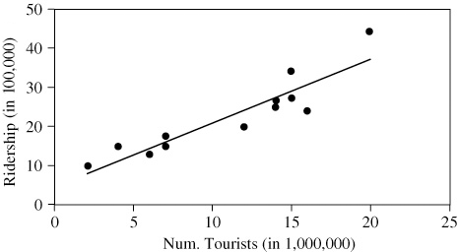
(b) Developing the regression relationship, we have:
(Summer | Tourists | Ridership
months) | (Millions) | (1,000,000s)
Year | (X) | (Y) | X² | Y² | XY
1 | 7 | 1.5 | 49 | 2.25 | 10.5
2 | 2 | 1.0 | 4 | 1.00 | 2.0
3 | 6 | 1.3 | 36 | 1.69 | 7.8
4 | 4 | 1.5 | 16 | 2.25 | 6.0
5 | 14 | 2.5 | 196 | 6.25 | 35.0
6 | 15 | 2.7 | 225 | 7.29 | 40.5
7 | 16 | 2.4 | 256 | 5.76 | 38.4
8 | 12 | 2.0 | 144 | 4.00 | 24.0
9 | 14 | 2.7 | 196 | 7.29 | 37.8
10 | 20 | 4.4 | 400 | 19.36 | 88.0
11 | 15 | 3.4 | 225 | 11.56 | 51.0
12 | 7 | 1.7 | 49 | 2.89 | 11.9
Given: Y = a + bX where:
and ΣX = 132, ΣY = 27.1, ΣXY = 352.9, ΣX² = 1796,
ΣY² = 71.59, = 11, = 2.26.
Then:
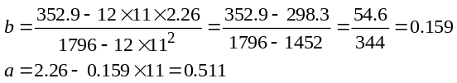
and Y = 0.511 + 0.159X
(c) Given a tourist population of 10,000,000, the model predicts a ridership of:
Y = 0.511 + 0.159 × 10 = 2.101, or 2,101,000 persons.
(d) If there are no tourists at all, the model predicts a ridership of 0.511, or 511,000 persons. One would not place much confidence in this forecast, however, because the number of tourists (zero) is outside the range of data used to develop the model.
(e) The standard error of the estimate is given by:
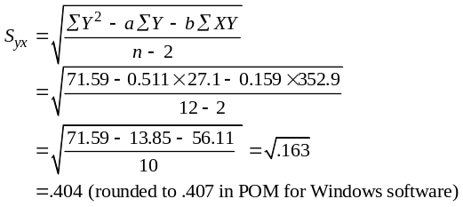
(f) The correlation coefficient and the coefficient of determination are given by:
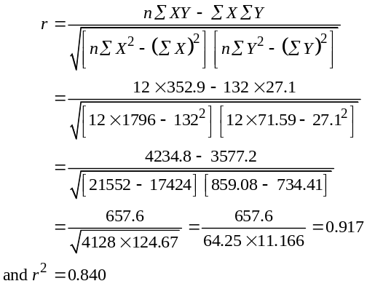
4.42 (a) This problem gives students a chance to tackle a realistic problem in business, i.e., not enough data to make a good forecast. As can be seen in the accompanying figure, the data contains both seasonal and trend factors.
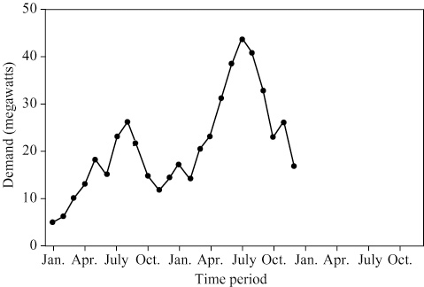
Averaging methods are not appropriate with trend, seasonal, or other patterns in the data. Moving averages smooth out seasonality. Exponential smoothing can forecast January next year,
but not farther. Because seasonality is strong, a naïve model that students create on their own might be best.
(b) One model might be: Ft+1 = At–11
That is forecastnext period = actualone year earlier to account for
seasonality. But this ignores the trend.
One very good approach would be to calculate the increase from each month last year to each month this year, sum all 12 increases, and divide by 12. The forecast for next year would equal the value for the same month this year plus the average increase over the 12 months of last year.
(c) Using this model, the January forecast for next year becomes:
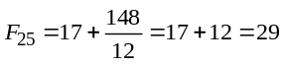
where 148 = total monthly increases from last year to this year.
The forecasts for each of the months of next year then become:
Jan. | 29 |  | July. | 56
Feb. | 26 |  | Aug. | 53
Mar. | 32 |  | Sep. | 45
Apr. | 35 |  | Oct. | 35
May. | 42 |  | Nov. | 38
Jun. | 50 |  | Dec. | 29
Both history and forecast for the next year are shown in the accompanying figure:
4.43 (a) and (b) See the following table:
 | Actual | Smoothed |  | Smoothed
Week | Value | Value | Forecast | Value | Forecast
t | A(t) | F_{t} (α = 0.2) | Error | F_{t} (α = 0.6) | Error
1 | 50 | +50.0 | +0.0 | +50.0 | +0.0
2 | 35 | +50.0 | –15.0 | +50.0 | –15.0
3 | 25 | +47.0 | –22.0 | +41.0 | –16.0
4 | 40 | +42.6 | –2.6 | +31.4 | +8.6
5 | 45 | +42.1 | –2.9 | +36.6 | +8.4
6 | 35 | +42.7 | –7.7 | +41.6 | –6.6
7 | 20 | +41.1 | –21.1 | +37.6 | –17.6
8 | 30 | +36.9 | –6.9 | +27.1 | +2.9
9 | 35 | +35.5 | –0.5 | +28.8 | +6.2
10 | 20 | +35.4 | –15.4 | +32.5 | –12.5
11 | 15 | +32.3 | –17.3 | +25.0 | –10.0
12 | 40 | +28.9 | +11.1 | +19.0 | +21.0
13 | 55 | +31.1 | +23.9 | +31.6 | +23.4
14 | 35 | +35.9 | –0.9 | +45.6 | –10.6
15 | 25 | +36.7 | –10.7 | +39.3 | –14.3
16 | 55 | +33.6 | +21.4 | +30.7 | +24.3
17 | 55 | +37.8 | +17.2 | +45.3 | +9.7
18 | 40 | +41.3 | –1.3 | +51.1 | –11.1
19 | 35 | +41.0 | –6.0 | +44.4 | –9.4
20 | 60 | +39.8 | +20.2 | +38.8 | +21.2
21 | 75 | +43.9 | +31.1 | +51.5 | +23.5
22 | 50 | +50.1 | –0.1 | +65.6 | –15.6
23 | 40 | +50.1 | –10.1 | +56.2 | –16.2
24 | 65 | +48.1 | +16.9 | +46.5 | +18.5
25 |  | +51.4 |  | +57.6
 |  | MAD = 11.8 |  | MAD = 13.45
(c) Students should note how stable the smoothed values are for α = 0.2. When compared to actual week 25 calls of 85, the smoothing constant, α = 0.6, appears to do a slightly better job. On the basis of the standard error
of the estimate and the MAD, the 0.2 constant is
better. However, other smoothing constants need to be examined.

To evaluate the trend adjusted exponential smoothing model, actual week 25 calls are compared to the forecasted value. The model appears to be producing a forecast approximately mid-range between that given by simple exponential smoothing using α = 0.2 and α = 0.6. Trend adjustment does not appear to give
any significant improvement.
4.44
Week | Actual Value | Smoothed Value | Trend Estimate | Forecast | Forecast
t | A_{t} | F_{t} (α = 0.3) | T_{t} (β = 0.2) | FIT_{t} | Error
1 | 50.000 | 50.000 | 0.000 | 50.000 | 0.000
2 | 35.000 | 50.000 | 0.000 | 50.000 | –15.000
3 | 25.000 | 45.500 | –0.900 | 44.600 | –19.600
4 | 40.000 | 38.720 | –2.076 | 36.644 | 3.356
5 | 45.000 | 37.651 | –1.875 | 35.776 | 9.224
6 | 35.000 | 38.543 | –1.321 | 37.222 | –2.222
7 | 20.000 | 36.555 | –1.455 | 35.101 | –15.101
8 | 30.000 | 30.571 | –2.361 | 28.210 | 1.790
9 | 35.000 | 28.747 | –2.253 | 26.494 | 8.506
10 | 20.000 | 29.046 | –1.743 | 27.303 | –7.303
11 | 15.000 | 25.112 | –2.181 | 22.931 | –7.931
12 | 40.000 | 20.552 | –2.657 | 17.895 | 22.105
13 | 55.000 | 24.526 | –1.331 | 23.196 | 31.804
14 | 35.000 | 32.737 | 0.578 | 33.315 | 1.685
15 | 25.000 | 33.820 | 0.679 | 34.499 | –9.499
16 | 55.000 | 31.649 | 0.109 | 31.758 | 23.242
17 | 55.000 | 38.731 | 1.503 | 40.234 | 14.766
18 | 40.000 | 44.664 | 2.389 | 47.053 | –7.053
19 | 35.000 | 44.937 | 1.966 | 46.903 | –11.903
20 | 60.000 | 43.332 | 1.252 | 44.584 | 15.416
21 | 75.000 | 49.209 | 2.177 | 51.386 | 23.614
22 | 50.000 | 58.470 | 3.594 | 62.064 | –12.064
23 | 40.000 | 58.445 | 2.870 | 61.315 | –21.315
24 | 65.000 | 54.920 | 1.591 | 56.511 | 8.489
25 |  | 59.058 | 2.100 | 61.158
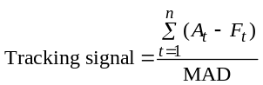

4.45

Month | A_{t} | F_{t} | |A_{t} – F_{t} | | (A_{t} – F_{t})
May | 100 | 100 | 0 | 0
June | 80 | 104 | 24 | –24
July | 110 | 99 | 11 | 11
August | 115 | 101 | 14 | 14
September | 105 | 104 | 1 | 1
October | 110 | 104 | 6 | 6
November | 125 | 105 | 20 | 20
December | 120 | 109 | 11 | 11
 |  |  | Sum: 87 | Sum: 39
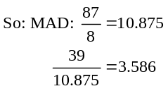

4.46 (a) |  |  | X |  | Y |  | X² |  | Y² |  | XY
 |  |  | 421 |  | 2.90 |  | 177241 |  | 8.41 |  | 1220.9
 |  |  | 377 |  | 2.93 |  | 142129 |  | 8.58 |  | 1104.6
 |  |  | 585 |  | 3.00 |  | 342225 |  | 9.00 |  | 1755.0
 |  |  | 690 |  | 3.45 |  | 476100 |  | 11.90 |  | 2380.5
 |  |  | 608 |  | 3.66 |  | 369664 |  | 13.40 |  | 2225.3
 |  |  | 390 |  | 2.88 |  | 152100 |  | 8.29 |  | 1123.2
 |  |  | 415 |  | 2.15 |  | 172225 |  | 4.62 |  | 892.3
 |  |  | 481 |  | 2.53 |  | 231361 |  | 6.40 |  | 1216.9
 |  |  | 729 |  | 3.22 |  | 531441 |  | 10.37 |  | 2347.4
 |  |  | 501 |  | 1.99 |  | 251001 |  | 3.96 |  | 997.0
 |  |  | 613 |  | 2.75 |  | 375769 |  | 7.56 |  | 1685.8
 |  |  | 709 |  | 3.90 |  | 502681 |  | 15.21 |  | 2765.1
 |  |  | 366 |  | 1.60 |  | 133956 |  | 2.56 |  | 585.6
 | Column totals |  | 6885 |  | 36.96 |  | 3857893 |  | 110.26 |  | 20299.5
Given: Y = a + bX where:
and ΣX = 6885, ΣY = 36.96, ΣXY = 20299.5, ΣX² = 3857893,
ΣY² = 110.26, = 529.6, = 2.843, Then:
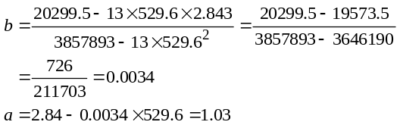
and Y = 1.03 + 0.0034X
As an indication of the usefulness of this relationship, we can calculate the correlation coefficient:
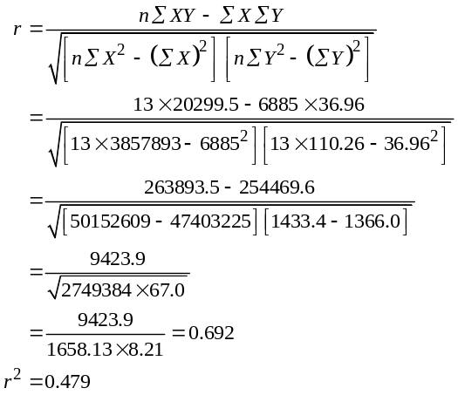
A correlation coefficient of 0.692 is not particularly high. The coefficient of determination, r2, indicates that the model explains only 47.9% of the overall variation. Therefore, while the model does provide an estimate of GPA, there is considerable variation in GPA, which is as yet unexplained. For
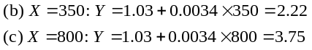
Note: When solving this problem, care must be taken to interpret significant digits. Also note that X = 800 is outside the range of the data set used to determine the regression relationship, so caution is advised.
4.47 (a) There is not a strong linear trend in sales over time.
(b, c) Amit wants to forecast by exponential smoothing (setting February’s forecast equal to January’s sales) with alpha = 0.1. Barbara wants to use a 3-period moving average.
 | Sales |  | Amit | Barbara | Amit Error |  |  | Barbara Error
January | 400 | — |  | — | — |  |  | —
February | 380 | 400 |  | — | 20.0 |  |  | —
March | 410 | 398 |  | — | 12.0 |  |  | —
April | 375 | 399.2 |  | 396.67 | 24.2 |  |  | 21.67
May | 405 | 396.8 |  | 388.33 | 8.22 |  |  | 16.67
 |  |  |  | MAD = |  | 16.11 |  |  | 19.17
(d) Note that Amit has more forecast observations, while Barbara’s moving average does not start until month 4. Also note that the MAD for Amit is an average of 4 numbers, while Barbara’s is only 2.
Amit’s MAD for exponential smoothing (16.11) is lower than that of Barbara’s moving average (19.17). So his forecast seems to be better.
4.48 (a)
Quarter | Contracts X |  |  | Sales Y |  |  | X² |  |  | Y² |  |  | XY
1 | 153 |  |  | 8 |  |  | 23,409 |  |  | 64 |  |  | 1,224
2 | 172 |  |  | 10 |  |  | 29,584 |  |  | 100 |  |  | 1,720
3 | 197 |  |  | 15 |  |  | 38,809 |  |  | 225 |  |  | 2,955
4 | 178 |  |  | 9 |  |  | 31,684 |  |  | 81 |  |  | 1,602
5 | 185 |  |  | 12 |  |  | 34,225 |  |  | 144 |  |  | 2,220
6 | 199 |  |  | 13 |  |  | 39,601 |  |  | 169 |  |  | 2,587
7 | 205 |  |  | 12 |  |  | 42,025 |  |  | 144 |  |  | 2,460
8 | 226 |  |  | 16 |  |  | 51,076 |  |  | 256 |  |  | 3,616
Totals |  | 1,515 |  |  | 95 |  |  | 290,413 |  |  | 1,183 |  |  | 18,384
Average | 189.375 |  |  | 11.875
b = (18384 – 8 × 189.375 × 11.875)/(290,413 – 8 × 189.375
× 189.375) = 0.1121
a = 11.875 – 0.1121 × 189.375 = –9.3495
Sales ( y) = –9.349 + 0.1121 (Contracts)
(b)
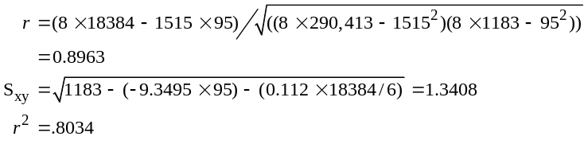
4.49 (a)
Method → Exponential Smoothing
 |  | 0.6 = α
Year | Deposits (Y) | Forecast | |Error| | Error²
1 | 0.25 | 0.25 | 0.00 | 0.00
2 | 0.24 | 0.25 | 0.01 | 0.0001
3 | 0.24 | 0.244 | 0.004 | 0.0000
4 | 0.26 | 0.241 | 0.018 | 0.0003
5 | 0.25 | 0.252 | 0.002 | 0.00
6 | 0.30 | 0.251 | 0.048 | 0.0023
7 | 0.31 | 0.280 | 0.029 | 0.0008
8 | 0.32 | 0.298 | 0.021 | 0.0004
9 | 0.24 | 0.311 | 0.071 | 0.0051
10 | 0.26 | 0.268 | 0.008 | 0.0000
11 | 0.25 | 0.263 | 0.013 | 0.0002
12 | 0.33 | 0.255 | 0.074 | 0.0055
13 | 0.50 | 0.300 | 0.199 | 0.0399
14 | 0.95 | 0.420 | 0.529 | 0.2808
15 | 1.70 | 0.738 | 0.961 | 0.925
16 | 2.30 | 1.315 | 0.984 | 0.9698
17 | 2.80 | 1.906 | 0.893 | 0.7990
18 | 2.80 | 2.442 | 0.357 | 0.1278
19 | 2.70 | 2.656 | 0.043 | 0.0018
20 | 3.90 | 2.682 | 1.217 | 1.4816
21 | 4.90 | 3.413 | 1.486 | 2.2108
22 | 5.30 | 4.305 | 0.994 | 0.9895
23 | 6.20 | 4.90 | 1.297 | 1.6845
24 | 4.10 | 5.680 | 1.580 | 2.499
25 | 4.50 | 4.732 | 0.232 | 0.0540
26 | 6.10 | 4.592 | 1.507 | 2.2712
27 | 7.70 | 5.497 | 2.202 | 4.8524
28 | 10.10 | 6.818 | 3.281 | 10.7658
29 | 15.20 | 8.787 | 6.412 | 41.1195
(Continued)
4.49 (a) (Continued)
Method → Exponential Smoothing
 |  |  |  | 0.6 = α
Year | Deposits (Y) |  |  | Forecast | |Error| |  |  | Error²
30 | 18.10 |  |  | 12.6350 | 5.46498 |  |  | 29.8660
31 | 24.10 |  |  | 15.9140 | 8.19 |  |  | 67.01
32 | 25.60 |  |  | 20.8256 | 4.774 |  |  | 22.7949
33 | 30.30 |  |  | 23.69 | 6.60976 |  |  | 43.69
34 | 36.00 |  |  | 27.6561 | 8.34390 |  |  | 69.62
35 | 31.10 |  |  | 32.6624 | 1.56244 |  |  | 2.44121
36 | 31.70 |  |  | 31.72 | 0.024975 |  |  | 0.000624
37 | 38.50 |  |  | 31.71 | 6.79 |  |  | 46.1042
38 | 47.90 |  |  | 35.784 | 12.116 |  |  | 146.798
39 | 49.10 |  |  | 43.0536 | 6.046 |  |  | 36.56
40 | 55.80 |  |  | 46.6814 | 9.11856 |  |  | 83.1481
41 | 70.10 |  |  | 52.1526 | 17.9474 |  |  | 322.11
42 | 70.90 |  |  | 62.9210 | 7.97897 |  |  | 63.66
43 | 79.10 |  |  | 67.7084 | 11.3916 |  |  | 129.768
44 | 94.00 |  |  | 74.5434 |  | 19.4566 |  |  | 378.561
TOTALS |  | 787.30 |  |  |  | 150.3 |  |  |  | 1,513.22
AVERAGE | 17.8932 |  |  |  | 3.416 |  |  | 34.39
 |  |  |  |  | (MAD) |  |  | (MSE)
Next period forecast = 86.2173 |  |  |  |  | Standard error = 6.07519

Method → Linear Regression (Trend Analysis)
Year | Period (X) |  |  |  |  | Deposits (Y) |  |  |  |  |  |  | Forecast |  | Error²
1 | 1 |  |  |  |  | 0.25 |  |  |  |  |  |  | –17.330 |  | 309.061
2 | 2 |  |  |  |  | 0.24 |  |  |  |  |  |  | –15.692 |  | 253.823
3 | 3 |  |  |  |  | 0.24 |  |  |  |  |  |  | –14.054 |  | 204.31
4 | 4 |  |  |  |  | 0.26 |  |  |  |  |  |  | –12.415 |  | 160.662
5 | 5 |  |  |  |  | 0.25 |  |  |  |  |  |  | –10.777 |  | 121.594
6 | 6 |  |  |  |  | 0.30 |  |  |  |  |  |  | –9.1387 |  | 89.0883
7 | 7 |  |  |  |  | 0.31 |  |  |  |  |  |  | –7.50 |  | 61.0019
8 | 8 |  |  |  |  | 0.32 |  |  |  |  |  |  | –5.8621 |  | 38.2181
9 | 9 |  |  |  |  | 0.24 |  |  |  |  |  |  | –4.2238 |  | 19.9254
10 | 10 |  |  |  |  | 0.26 |  |  |  |  |  |  | –2.5855 |  | 8.09681
11 | 11 |  |  |  |  | 0.25 |  |  |  |  |  |  | –0.947 |  | 1.43328
12 | 12 |  |  |  |  | 0.33 |  |  |  |  |  |  | 0.691098 |  | 0.130392
13 | 13 |  |  |  |  | 0.50 |  |  |  |  |  |  | 2.329 |  | 3.34667
14 | 14 |  |  |  |  | 0.95 |  |  |  |  |  |  | 3.96769 |  | 9.10642
15 | 15 |  |  |  |  | 1.70 |  |  |  |  |  |  | 5.60598 |  | 15.2567
16 | 16 |  |  |  |  | 2.30 |  |  |  |  |  |  | 7.24427 |  | 24.4458
17 | 17 |  |  |  |  | 2.80 |  |  |  |  |  |  | 8.88257 |  | 36.9976
18 | 18 |  |  |  |  | 2.80 |  |  |  |  |  |  | 10.52 |  | 59.6117
19 | 19 |  |  |  |  | 2.70 |  |  |  |  |  |  | 12.1592 |  | 89.4756
20 | 20 |  |  |  |  | 3.90 |  |  |  |  |  |  | 13.7974 |  | 97.9594
21 | 21 |  |  |  |  | 4.90 |  |  |  |  |  |  | 15.4357 |  | 111.0
22 | 22 |  |  |  |  | 5.30 |  |  |  |  |  |  | 17.0740 |  | 138.628
23 | 23 |  |  |  |  | 6.20 |  |  |  |  |  |  | 18.7123 |  | 156.558
24 | 24 |  |  |  |  | 4.10 |  |  |  |  |  |  | 20.35 |  | 264.083
25 | 25 |  |  |  |  | 4.50 |  |  |  |  |  |  | 21.99 |  | 305.862
26 | 26 |  |  |  |  | 6.10 |  |  |  |  |  |  | 23.6272 |  | 307.203
27 | 27 |  |  |  |  | 7.70 |  |  |  |  |  |  | 25.2655 |  | 308.547
28 | 28 |  |  |  |  | 10.10 |  |  |  |  |  |  | 26.9038 |  | 282.367
29 | 29 |  |  |  |  | 15.20 |  |  |  |  |  |  | 28.5421 |  | 178.011
30 | 30 |  |  |  |  | 18.10 |  |  |  |  |  |  | 30.18 |  | 145.936
31 | 31 |  |  |  |  | 24.10 |  |  |  |  |  |  | 31.8187 |  | 59.58
32 | 32 |  |  |  |  | 25.60 |  |  |  |  |  |  | 33.46 |  | 61.73
33 | 33 |  |  |  |  | 30.30 |  |  |  |  |  |  | 35.0953 |  | 22.9945
34 | 34 |  |  |  |  | 36.00 |  |  |  |  |  |  | 36.7336 |  | 0.5381
35 | 35 |  |  |  |  | 31.10 |  |  |  |  |  |  | 38.3718 |  | 52.8798
36 | 36 |  |  |  |  | 31.70 |  |  |  |  |  |  | 40.01 |  | 69.0585
37 | 37 |  |  |  |  | 38.50 |  |  |  |  |  |  | 41.6484 |  | 9.91266
38 | 38 |  |  |  |  | 47.90 |  |  |  |  |  |  | 43.2867 |  | 21.2823
39 | 39 |  |  |  |  |  | 49.10 |  |  |  |  |  | 44.9250 |  | 17.43
40 | 40 |  |  |  |  |  | 55.80 |  |  |  |  |  | 46.5633 |  | 85.3163
41 | 41 |  |  |  |  |  | 70.10 |  |  |  |  |  | 48.2016 |  | 479.54
42 | 42 |  |  |  |  |  | 70.90 |  |  |  |  |  | 49.84 |  | 443.528
43 | 43 |  |  |  |  |  | 79.10 |  |  |  |  |  | 51.4782 |  | 762.964
44 | 44 |  |  |  |  |  | 94.00 |  |  |  |  |  | 53.1165 |  | 1,671.46
TOTALS |  | 990.00 |  |  |  |  |  | 787.30 |  |  |  |  |  |  |  | 7,559.95
AVERAGE |  |  | 22.50 |  |  |  |  |  | 17.893 |  |  |  |  | 171.817
 |  |  |  |  |  |  |  |  |  |  |  |  |  | (MSE)

Method → Least squares–Simple Regression on GSP
 |  | a |  |  | b
 | –17.636 |  |  | 13.5936
Coefficients: | GSP |  | Deposits
Year | (X) |  | (Y) |  | Forecast |  | |Error| | Error²
1 | 0.40 |  | 0.25 |  | –12.198 |  | 12.4482 | 154.957
2 | 0.40 |  | 0.24 |  | –12.198 |  | 12.4382 | 154.71
3 | 0.50 |  | 0.24 |  | –10.839 |  | 11.0788 | 122.740
4 | 0.70 |  | 0.26 |  | –8.12 |  | 8.38 | 70.226
5 | 0.90 |  | 0.25 |  | –5.4014 |  | 5.65137 | 31.94
6 | 1.00 |  | 0.30 |  | –4.0420 |  | 4.342 | 18.8530
7 | 1.40 |  | 0.31 |  | 1.39545 |  | 1.08545 | 1.17820
8 | 1.70 |  | 0.32 |  | 5.47354 |  | 5.15354 | 26.56
9 | 1.30 |  | 0.24 |  | 0.036086 |  | 0.203914 | 0.041581
10 | 1.20 |  | 0.26 |  | –1.3233 |  | 1.58328 | 2.50676
11 | 1.10 |  | 0.25 |  | –2.6826 |  | 2.93264 | 8.60038
12 | 0.90 |  | 0.33 |  | –5.4014 |  | 5.73137 | 32.8486
13 | 1.20 |  | 0.50 |  | –1.3233 |  | 1.82328 | 3.32434
14 | 1.20 |  | 0.95 |  | –1.3233 |  | 2.27328 | 5.16779
15 | 1.20 |  | 1.70 |  | –1.3233 |  | 3.02328 | 9.14020
16 | 1.60 |  | 2.30 |  | 4.11418 |  | 1.81418 | 3.29124
17 | 1.50 |  | 2.80 |  | 2.75481 |  | 0.045186 | 0.002042
18 | 1.60 |  | 2.80 |  | 4.11418 |  | 1.31418 | 1.727
19 | 1.70 |  | 2.70 |  | 5.47354 |  | 2.77354 | 7.69253
20 | 1.90 |  | 3.90 |  | 8.19227 |  | 4.29227 | 18.4236
21 | 1.90 |  | 4.90 |  | 8.19227 |  | 3.29227 | 10.8390
22 | 2.30 |  | 5.30 |  | 13.6297 |  | 8.32972 | 69.3843
23 | 2.50 |  | 6.20 |  | 16.3484 |  | 10.1484 | 102.991
24 | 2.80 |  | 4.10 |  | 20.4265 |  | 16.3265 | 266.556
25 | 2.90 |  | 4.50 |  | 21.79 |  | 17.29 | 298.80
26 | 3.40 |  | 6.10 |  | 28.5827 |  | 22.4827 | 505.473
27 | 3.80 |  | 7.70 |  | 34.02 |  | 26.32 | 692.752
28 | 4.10 |  | 10.10 |  | 38.0983 |  | 27.9983 | 783.90
29 | 4.00 |  | 15.20 |  | 36.74 |  | 21.54 | 463.924
30 | 4.00 |  | 18.10 |  | 36.74 |  | 18.64 | 347.41
31 | 3.90 |  | 24.10 |  | 35.3795 |  | 11.2795 | 127.228
32 | 3.80 |  | 25.60 |  | 34.02 |  | 8.42018 | 70.8994
33 | 3.80 |  | 30.30 |  | 34.02 |  | 3.72018 | 13.8397
34 | 3.70 |  | 36.00 |  | 32.66 |  | 3.33918 | 11.15
35 | 4.10 |  | 31.10 |  | 38.0983 |  | 6.99827 | 48.9757
36 | 4.10 |  | 31.70 |  | 38.0983 |  | 6.39827 | 40.9378
37 | 4.00 |  | 38.50 |  | 36.74 |  | 1.76 | 3.10146
38 | 4.50 |  | 47.90 |  | 43.5357 |  | 4.36428 | 19.05
39 | 4.60 |  | 49.10 |  | 44.8951 |  | 4.20491 | 17.6813
40 | 4.50 |  | 55.80 |  | 43.5357 |  | 12.2643 | 150.412
41 | 4.60 |  | 70.10 |  | 44.8951 |  | 25.20 | 635.288
42 | 4.60 |  | 70.90 |  | 44.8951 |  | 26.00 | 676.256
43 | 4.70 |  | 79.10 |  | 46.2544 |  | 32.8456 | 1,078.83
44 | 5.00 |  | 94.00 |  | 50.3325 |  | 43.6675 | 1,906.85
TOTALS |  |  |  |  |  |  | 451.223 | 9,016.45
AVERAGE |  |  |  |  |  |  | 10.2551 | 204.92
 |  |  |  |  |  |  | (MAD) | (MSE)
Given that one wishes to develop a five-year forecast, trend analysis is the appropriate choice. Measures of error and goodness-of-fit are really irrelevant. Exponential smoothing provides a forecast only of deposits for the next year—and thus does not address the five-year forecast problem. In order to use the regression model based upon GSP, one must first develop a model to forecast GSP, and then use the forecast of GSP in the model to forecast deposits. This requires the development of two models—one of which (the model for GSP) must be based solely on time as the independent variable (time is the only other variable we are given).
Forecasting Summary Table
 | Exponential | Linear Regression
Method used: | Smoothing | (Trend Analysis) | Linear Regression
 |  | Y = –18.968 + | Y = –17.636 +
 |  | 1.638 × YEAR | 13.59364 × GSP
MAD | 3.416 | 10.587 | 10.255
MSE | 34.39 | 171.817 | 204.919
Standard error using | 6.075 | 13.416 | 14.651
n – 2 in denominator
Correlation coefficient |  | 0.846 | 0.813

(b) One could make a case for exclusion of the older data. Were we to exclude data from roughly the first 25 years, the forecasts for the later years would likely be considerably more accurate. Our argument would be that a change that caused an increase in the rate of growth appears to have taken place at the end of that period. Exclusion of this data, however, would not change our choice of forecasting model because we still need to forecast deposits for a future five-year period.
Additional Homework Problems
These problems, which appear on www.pearsonglobaleditions.com/myomlab, provide an additional 13 problems that you may wish to assign.
4.50
 | Week | 1 | 2 | 3 | 4 | 5 | 6 | 7 | 8 | 9 | 10 | Forecast
 | Registration | 22 | 21 | 25 | 27 | 35 | 29 | 33 | 37 | 41 | 37
(a) | Naïve |  | 22 | 21 | 25 | 27 | 35 | 29 | 33 | 37 | 41 | 37
(b) | 2-week moving |  |  | 21.5 | 23 | 26 | 31 | 32 | 31 | 35 | 39 | 39
(c) | 4-week moving |  |  |  |  | 23.75 | 27 | 29 | 31 | 33.5 | 35 | 37

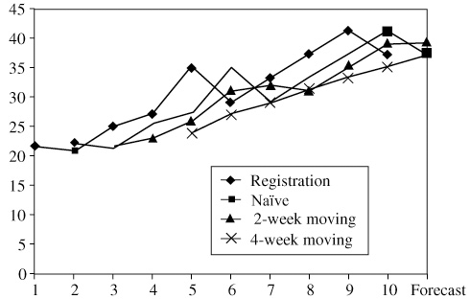
4.51
Period | Demand | Exponentially Smoothed Forecast
1 | 7 | 5
2 | 9 | 5 + 0.2 × (7 – 5) = 5.4
3 | 5 | 5.4 + 0.2 × (9 – 5.4) = 6.12
4 | 9 | 6.12 + 0.2 × (5 – 6.12) = 5.90
5 | 13 | 5.90 + 0.2 × (9 – 5.90) = 6.52
6 | 8 | 6.52 + 0.2 × (13 – 6.52) = 7.82
7 | Forecast | 7.82 + 0.2 × (8 – 7.82) = 7.86
4.52
Actual | Forecast | |Error| |  |  | Error²
95 | 100 | 5 |  |  | 25
108 | 110 | 2 |  |  | 4
123 | 120 | 3 |  |  | 9
130 | 130 | 0 |  |  | 0
 |  |  | 10 |  |  | 38
MAD = 10/4 = 2.5, MSE = 38/4 = 9.5
4.53 (a) 3-month moving average:
 |  | Three-Month | Absolute
Month | Sales | Moving Average | Deviation
January | 11
February | 14
March | 16
April | 10 | (11 + 14 + 16)/3 = 13.67 | 3.67
May | 15 | (14 + 16 + 10)/3 = 13.33 | 1.67
June | 17 | (16 + 10 + 15)/3 = 13.67 | 3.33
July | 11 | (10 + 15 + 17)/3 = 14.00 | 3.00
August | 14 | (15 + 17 + 11)/3 = 14.33 | 0.33
September | 17 | (17 + 11 + 14)/3 = 14.00 | 3.00
October | 12 | (11 + 14 + 17)/3 = 14.00 | 2.00
November | 14 | (14 + 17 + 12)/3 = 14.33 | 0.33
December | 16 | (17 + 12 + 14)/3 = 14.33 | 1.67
January | 11 | (12 + 14 + 16)/3 = 14.00 | 3.00
February |  | (14 + 16 + 11)/3 = 13.67
Σ = 22.00
MAD = 2.20
(b) 3-month weighted moving average
Month | Sales | Three-Month Moving Average Moving | Absolute Deviation
January | 11
February | 14
March | 16
April | 10 | (1 × 11 + 2 × 14 + 3 × 16)/6 = 14.50 | 4.50
May | 15 | (1 × 14 + 2 × 16 + 3 × 10)/6 = 12.67 | 2.33
June | 17 | (1 × 16 + 2 × 10 + 3 × 15)/6 = 13.50 | 3.50
July | 11 | (1 × 10 + 2 × 15 + 3 × 17)/6 = 15.17 | 4.17
August | 14 | (1 × 15 + 2 × 17 + 3 × 11)/6 = 13.67 | 0.33
September | 17 | (1 × 17 + 2 × 11 + 3 × 14)/6 = 13.50 | 3.50
October | 12 | (1 × 11 + 2 × 14 + 3 × 17)/6 = 15.00 | 3.00
November | 14 | (1 × 14 + 2 × 17 + 3 × 12)/6 = 14.00 | 0.00
December | 16 | (1 × 17 + 2 × 12 + 3 × 14)/6 = 13.83 | 2.17
January | 11 | (1 × 12 + 2 × 14 + 3 × 16)/6 = 14.67 | 3.67
February |  | (1 × 14 + 2 × 16 + 3 × 11)/6 = 13.17
Σ = 27.17
MAD = 2.72
(c) Based on a Mean Absolute Deviation criterion, the
3-month moving average with MAD = 2.2 is to be preferred over the 3-month weighted moving average with MAD = 2.72.
(d) Other factors that might be included in a more complex model are interest rates and cycle or seasonal factors.
4.54 (a)
 | Actual |  |  | Cumulative |  | Cum. | Tracking
Week | Miles | Forecast | Error | Error | Σ |Error| | MAD | Signal
1 | 17 | 17.00 | 0.00 | – | 0.00 | 0
2 | 21 | 17.00 | –4.00 | –4.00 | 4.00 | 2 | –2
3 | 19 | 17.80 | –1.20 | –5.20 | 5.20 | 1.73 | –3
4 | 23 | 18.04 | –4.96 | –10.16 | 10.16 | 2.54 | –4
5 | 18 | 19.03 | +1.03 | –9.13 | 11.19 | 2.24 | –4
6 | 16 | 18.83 | +2.83 | –6.30 | 14.02 | 2.34 | –2.7
7 | 20 | 18.26 | –1.74 | –8.04 | 15.76 | 2.25 | –3.6
8 | 18 | 18.61 | +0.61 | –7.43 | 16.37 | 2.05 | –3.6
9 | 22 | 18.49 | –3.51 | –10.94 | 19.88 | 2.21 | –5
10 | 20 | 19.19 | –0.81 | –11.75 | 20.69 | 2.07 | –5.7
11 | 15 | 19.35 | +4.35 | –7.40 | 25.04 | 2.28 | –3.2
12 | 22 | 18.48 | –3.52 | –10.92 | 28.56 | 2.38 | –4.6
(b) The MAD = 28.56/12 = 2.38
(c) The cumulative error and tracking signals appear to
be consistently negative, and at week 10, the tracking signal exceeds 5 MADs.
4.55 | y | x | x² | xy
 | 7 | 1 | 1 | 7
 | 9 | 2 | 4 | 18
 | 5 | 3 | 9 | 15
 | 11 | 4 | 16 | 44
 | 10 | 5 | 25 | 50
 | 13 | 6 | 36 | 78
 | 55 | 21 | 91 | 212
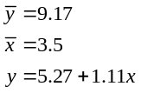
Period 7 forecast = 13.07
Period 12 forecast = 18.64, but this is far outside the range of valid data.
4.56 To compute seasonalized or adjusted sales forecast, we just multiply each seasonalized index by the appropriate trend forecast.
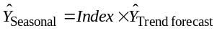
Hence, for
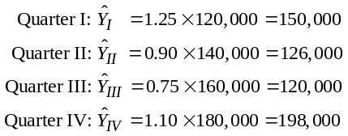
4.57
 | Mon |  |  | Tue |  |  | Wed |  |  | Thu |  |  | Fri |  |  | Sat
Week 1 | 210 |  |  | 178 |  |  | 250 |  |  | 215 |  |  | 160 |  |  | 180
Week 2 | 215 |  |  | 180 |  |  | 250 |  |  | 213 |  |  | 165 |  |  | 185
Week 3 | 220 |  |  | 176 |  |  | 260 |  |  | 220 |  |  | 175 |  |  | 190
Week 4 | 225 |  |  | 178 |  |  | 260 |  |  | 225 |  |  | 176 |  |  | 190
Averages |  | 217.5 |  |  | 178 |  |  | 255 |  |  | 218.3 |  |  | 169 |  |  | 186.3 |  |  | Overall average = 204

(a) Seasonal indices:
1.066 (Mon) 0.873 (Tue) 1.25 (Wed)
1.07 (Thu) 0.828 (Fri) 0.913 (Sat)
(b) To calculate for Monday of Week 5 = 201.74 +
0.18(25) × 1.066 = 219.9 rounded to 220
Forecast 220 (Mon) 180 (Tue) 258 (Wed)
221 (Thu) 171 (Fri) 189 (Sat)
4.58 (a) 4000 + 0.20(15,000) = 7,000
(b) 4000 + 0.20(25,000) = 9,000
4.59 (a) 35 + 20(80) + 50(3.0) = 1,785
(b) 35 + 20(70) + 50(2.5) = 1,560
4.60 Given: ΣX = 15, ΣY = 20, ΣXY = 70, ΣX2 = 55, ΣY2 = 130, = 3, = 4
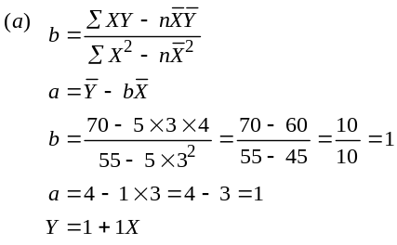
(b) Correlation coefficient:
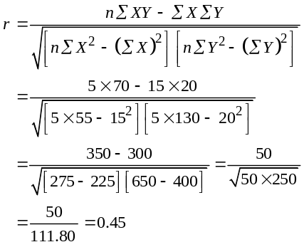
The correlation coefficient indicates that there is a positive
correlation between bank deposits and consumer price indices in

Birmingham, Alabama—i.e., as one variable tends to increase (or decrease), the other tends to increase (or decrease).
4.60 (c) Standard error of the estimate:
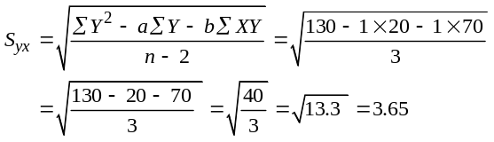
4.61
 | X | Y | X² | Y² | XY
 | 2 | 4 | 4 | 16 | 8
 | 1 | 1 | 1 | 1 | 1
 | 4 | 4 | 16 | 16 | 16
 | 5 | 6 | 25 | 36 | 30
 | 3 | 5 | 9 | 25 | 15
Column Totals | 15 | 20 | 55 | 94 | 70
Given: Y = a + bX where:
and ΣX = 15, ΣY = 20, ΣXY = 70, ΣX2 = 55, ΣY2 = 94, = 3,
= 4. Then:
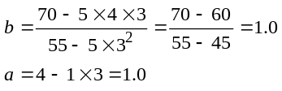
and Y = 1.0 + 1.0X. The correlation coefficient:

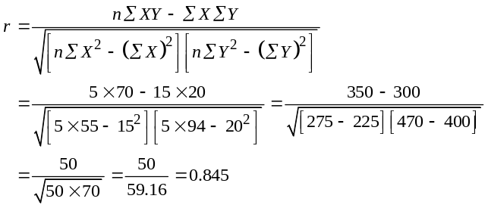
Standard error of the estimate:
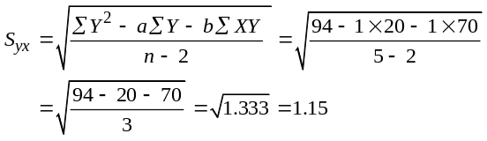
4.62 Using software, the regression equation is: Games lost = 6.41 + 0.533 × days rain.
Case Studies
SOUTHWESTERN UNIVERSITY: B
1
This is the second in a series of integrated case studies that run throughout the text.
1. One way to address the case is with separate forecasting models for each game. Clearly, the homecoming game (week 2) and the fourth game (craft festival) are unique attendance situations.
 |  | Forecasts
Game | Model | 2010 |  |  | 2011 |  |  | R²
1 | y = 30,713 + 2,534x | 48,453 |  |  | 50,988 |  |  | 0.92
2 | y = 37,640 + 2,146x | 52,660 |  |  | 54,806 |  |  | 0.90
3 | y = 36,940 + 1,560x | 47,860 |  |  | 49,420 |  |  | 0.91
4 | y = 22,567 + 2,143x | 37,567 |  |  | 39,710 |  |  | 0.88
5 | y = 30,440 + 3,146x | 52,460 |  |  | 55,606 |  |  | 0.93
Total |  |  | 239,000 |  |  | 250,530
(where y = attendance and x = time)
2. Revenue in 2010 = (239,000) ($50/ticket) = $11,950,000
Revenue in 2011 = (250,530) ($52.50/ticket) = $13,152,825
3. In games 2 and 5, the forecast for 2011 exceeds stadium capacity. With this appearing to be a continuing trend, the time has come for a new or expanded stadium.

DIGITAL CELL PHONE, INC.
2
Objectives:
- Selection of an appropriate time series forecasting model based upon a plot of the data.
- The importance of combining a qualitative model with a quantitative model in situations where technological change is occurring.

1. A plot of the data indicates a linear trend (least squares) model might be appropriate for forecasting. Using linear trend you obtain the following:
 |  | x |  | y |  | x² |  | xy |  | y²
 |  | 1 |  | 480 |  | 1 |  | 480 |  | 230,400
 |  | 2 |  | 436 |  | 4 |  | 872 |  | 190,096
 |  | 3 |  | 482 |  | 9 |  | 1,446 |  | 232,324
 |  | 4 |  | 448 |  | 16 |  | 1,792 |  | 200,704
 |  | 5 |  | 458 |  | 25 |  | 2,290 |  | 209,464
 |  | 6 |  | 489 |  | 36 |  | 2,934 |  | 239,121
 |  | 7 |  | 498 |  | 49 |  | 3,486 |  | 248,004
 |  | 8 |  | 430 |  | 64 |  | 3,440 |  | 184,900
 |  | 9 |  | 444 |  | 81 |  | 3,996 |  | 197,136
 |  | 10 |  | 496 |  | 100 |  | 4,960 |  | 246,016
 |  | 11 |  | 487 |  | 121 |  | 5,357 |  | 237,169
 |  | 12 |  | 525 |  | 144 |  | 6,300 |  | 275,625
 |  | 13 |  | 575 |  | 169 |  | 7,475 |  | 330,625
 |  | 14 |  | 527 |  | 196 |  | 7,378 |  | 277,729
 |  | 15 |  | 540 |  | 225 |  | 8,100 |  | 291,600
 |  | 16 |  | 502 |  | 256 |  | 8,032 |  | 252,004
 |  | 17 |  | 508 |  | 289 |  | 8,636 |  | 258,064
 |  | 18 |  | 573 |  | 324 |  | 10,314 |  | 328,329
 |  | 19 |  | 508 |  | 361 |  | 9,652 |  | 258,064
 |  | 20 |  | 498 |  | 400 |  | 9,960 |  | 248,004
 |  | 21 |  | 485 |  | 441 |  | 10,185 |  | 235,225
 |  | 22 |  | 526 |  | 484 |  | 11,572 |  | 276,676
 |  | 23 |  | 552 |  | 529 |  | 12,696 |  | 304,704
 |  | 24 |  | 587 |  | 576 |  | 14,088 |  | 344,569
 |  | 25 |  | 608 |  | 625 |  | 15,200 |  | 369,664
 |  | 26 |  | 597 |  | 676 |  | 15,522 |  | 356,409
 |  | 27 |  | 612 |  | 729 |  | 16,524 |  | 374,544
 |  | 28 |  | 603 |  | 784 |  | 16,884 |  | 363,609
 |  | 29 |  | 628 |  | 841 |  | 18,212 |  | 394,384
 |  | 30 |  | 605 |  | 900 |  | 18,150 |  | 366,025
 |  | 31 |  | 627 |  | 961 |  | 19,437 |  | 393,129
 |  | 32 |  | 578 |  | 1,024 |  | 18,496 |  | 334,084
 |  | 33 |  | 585 |  | 1,089 |  | 19,305 |  | 342,225
 |  | 34 |  | 581 |  | 1,156 |  | 19,754 |  | 337,561
 |  | 35 |  | 632 |  | 1,225 |  | 22,120 |  | 399,424
 |  | 36 |  | 656 |  | 1,296 |  | 23,616 |  | 430,336
Totals | 666 |  | 19,366 |  | 16,206 |  | 378,661 |  | 10,558,246
Average |  | 18.5 |  | 537.9 |  | 450.2 | 10,518.4 |  |  | 293,284.6
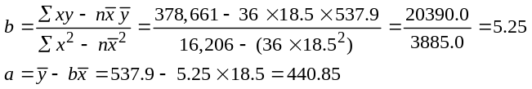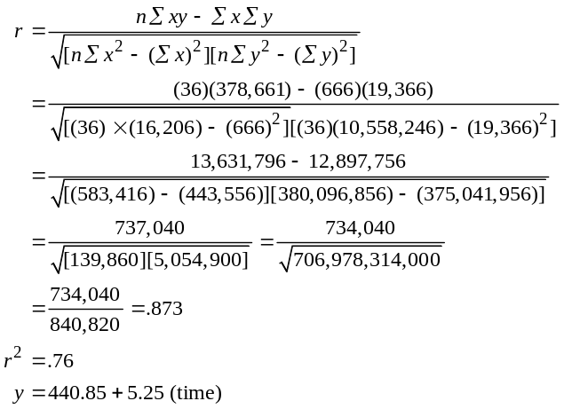
r = 0.873 indicating a reasonably good fit
The student should report the linear trend results, but deflate the forecast obtained based upon qualitative information about industry and technology trends.
Because there is limited seasonality in the data, the linear trend analysis above provides a good r² of .76.
However, a more precise forecast can be developed addressing the seasonality issue, which is done below. Methods a and c yield r² of .85 and .86, respectively, and methods b and d, which also center the seasonal adjustment, yield r² of .93 and .94, respectively.
2. Four approaches to decomposition of The Digital Cell Phone data can address seasonality, as follows:
a) Multiplicative seasonal model,
Cases = 443.87 + 5.08 (time), r² = .85, MAD = 20.89
b) Multiplicative Seasonal Model, with centered moving averages (CMA), which is not covered in our text but can be seen in Render, Stair, and Hanna’s Quantitative Analysis for Management, 10th ed., Prentice Hall Publishing.
Cases = 432.28 + 5.73 (time), r² = .93, MAD = 12.84
c) Additive seasonal model,
Cases = 444.29 + 5.06 (time), r² = .86, MAD = 20.02
d) Additive seasonal model, with centered moving averages.
Cases = 431.31 + 5.72 (time), r² = .94, MAD = 12.28
The two methods that use the average of all data have very similar results, and the two CMA methods also look quite close. As suggested with this analysis, CMA is typically the better technique.
Video Case Study
FORECASTING AT HARD ROCK CAFE
There is a short video (8 minutes) available from Pearson Education and filmed specifically for this text that supplements this case.
1. Hard Rock uses forecasting for (1) sales (guest counts) at cafes, (2) retail sales, (3) banquet sales, (4) concert sales, (5) evaluating managers, and (6) menu planning. They could also employ these techniques to forecast: retail store sales of individual (SKU) product demands; sales of each entrée; sales at each work station, etc.
2. The POS system captures all the basic sales data needed to drive individual cafe’s scheduling/ordering. It also is aggregated at corporate HQ. Each entrée sold is counted as one guest at a Hard Rock Cafe.
3. The weighting system is subjective, but is reasonable. More weight is given to each of the past 2 years than to 3 years ago. This system actually protects managers from large sales variations outside their control. One could also justify a 50%–30%–20% model or some other variation.
4. Other predictors of cafe sales could include season of year (weather); hotel occupancy; spring break from colleges; beef prices; promotional budget; etc.
5. Y = a + bx
Month | Advertising X |  |  | Guest Count Y |  |  | X² |  |  |  | Y² | XY
1 | 14 |  |  | 21 |  |  | 196 |  |  |  | 441 | 294
2 | 17 |  |  | 24 |  |  | 289 |  |  |  | 576 | 408
3 | 25 |  |  | 27 |  |  | 625 |  |  |  | 729 | 675
4 | 25 |  |  | 32 |  |  | 625 |  |  |  | 1,024 | 800
5 | 35 |  |  | 29 |  |  | 1,225 |  |  |  | 841 | 1,015
6 | 35 |  |  | 37 |  |  | 1,225 |  |  |  | 1,369 | 1,295
7 | 45 |  |  | 43 |  |  | 2,025 |  |  |  | 1,849 | 1,935
8 | 50 |  |  | 43 |  |  | 2,500 |  |  |  | 1,849 | 2,150
9 | 60 |  |  | 54 |  |  | 3,600 |  |  |  | 2,916 | 3,240
10 | 60 |  |  | 66 |  |  |  | 3,600 |  |  | 4,356 | 3,960
Totals |  | 366 |  |  | 376 |  | 15,910 |  |  |  | 15,950 |  | 15,772
Average | 36.6 |  |  | 37.6
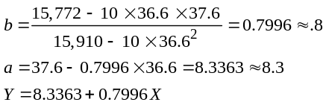
At $65,000; y = 8.3 + .8 (65) = 8.3 + 52 = 60.3, or 60,300 guests.
For the instructor who asks other questions than this one:
r² = 0.8869
Std. error = 5.062

Additional Case Study*
THE NORTH-SOUTH AIRLINE
Northern Airline Data
 | Airframe Cost | Engine Cost | Average
Year | per Aircraft | per Aircraft | Age (hrs)
2003 | 51.80 | 43.49 | 6512
2004 | 54.92 | 38.58 | 8404
2005 | 69.70 | 51.48 | 11077
2006 | 68.90 | 58.72 | 11717
2007 | 63.72 | 45.47 | 13275
2008 | 84.73 | 50.26 | 15215
2009 | 78.74 | 79.60 | 18390

Southeast Airline Data
 | Airframe Cost | Engine Cost | Average
Year | per Aircraft | per Aircraft | Age (hrs)
2003 | 13.29 | 18.86 | 5107
2004 | 25.15 | 31.55 | 8145
2005 | 32.18 | 40.43 | 7360
2006 | 31.78 | 22.10 | 5773
2007 | 25.34 | 19.69 | 7150
2008 | 32.78 | 32.58 | 9364
2009 | 35.56 | 38.07 | 8259

Utilizing the software package provided with this text, we can develop the following regression equations for the variables of interest:
Northern Airlines—Airframe Maintenance Cost:
- Cost = 36.10 + 0.0026 × Airframe age
- Coefficient of determination = 0.7695
- Coefficient of correlation = 0.8772
Northern Airlines—Engine Maintenance Cost:
- Cost = 20.57 + 0.0026 × Airframe age
- Coefficient of determination = 0.6124
- Coefficient of correlation = 0.7825
Southeast Airlines—Airframe Maintenance Cost:
- Cost = 4.60 + 0.0032 × Airframe age
- Coefficient of determination = 0.3905
- Coefficient of correlation = 0.6249
Southeast Airlines—Engine Maintenance Cost;
- Cost = –0.67 + 0.0041 × Airframe age
- Coefficient of determination = 0.4600
- Coefficient of correlation = 0.6782
The following graphs portray both the actual data and the regression lines for airframe and engine maintenance costs for both airlines.
*This case study appears on our companion Web site, at
www.pearsonglobaleditions.com/heizer, and at www.pearsonglobaleditions.com/myomlab.

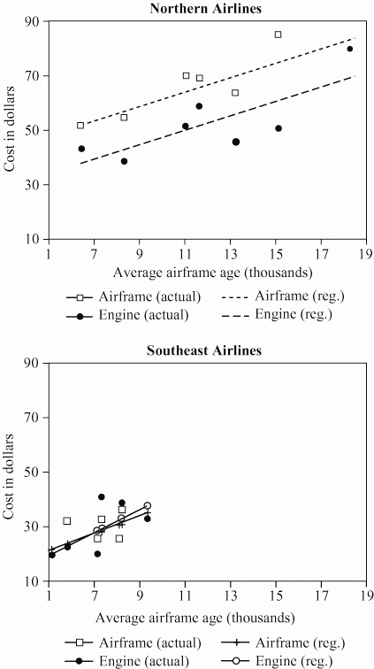

Note that the two graphs have been drawn to the same scale to facilitate comparisons between the two airlines.
Comparison:
- Northern Airlines: There seem to be modest correlations between maintenance costs and airframe age for Northern Airlines. There is certainly reason to conclude, however, that airframe age is not the only important factor.

- Southeast Airlines: The relationships between mainte-nance costs and airframe age for Southeast Airlines are much less well defined. It is even more obvious that airframe age is not the only important factor—perhaps not even the most important factor.
Overall, it would seem that:
- Northern Airlines has the smallest variance in mainte-nance costs—indicating that its day-to-day management
of maintenance is working pretty well.
- Maintenance costs seem to be more a function of airline than of airframe age.
- The airframe and engine maintenance costs for Southeast Airlines are not only lower, but more nearly similar than those for Northern Airlines. From the graphs, at least, they appear to be rising more sharply with age.
- From an overall perspective, it appears that Southeast Airlines may perform more efficiently on sporadic or emergency
repairs, and Northern Airlines may place more emphasis on preventive maintenance.
Ms. Young’s report should conclude that:
- There is evidence to suggest that maintenance costs could be made to be a function of airframe age by implementing more effective management practices.
- The difference between maintenance procedures of the two airlines should be investigated.

- The data with which she is currently working does not provide conclusive results.
Concluding Comment:
The question always arises, with this case, as to whether the data should be merged for the two airlines, resulting in two regressions instead of four. The solution provided is that of the consultant who was hired to analyze the data. The airline’s own internal analysts also conducted regressions, but did merge the data sets. This shows how statisticians can take different views of the same data.

